Accessing the Learning Platform
GO and the Learning Platform are two separate systems, but they do talk to each other and you will use the same username to access both. You may set different passwords for each though.
You will need a GO log in
If you already have a GO log in, jump to the next step. You will need your GO username only for the Learning Platform.
If you haven't got your GO username, follow these steps first.
1. Follow the link to GO | GO
2. If you have used GO in the past but can't remember your log in details, then use either the 'Forgot your username?' or 'Forgot your password?' links to request new details.  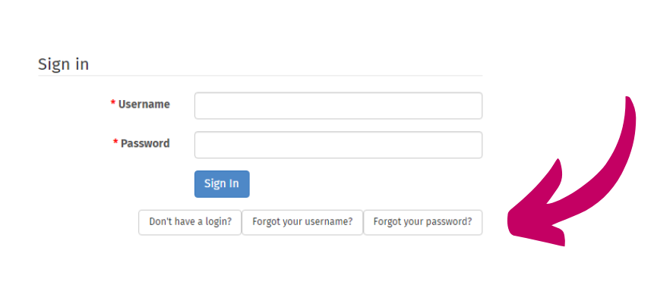 | 2. If you have never used GO then use the 'Don't have a login?' link and follow the onscreen instructions.  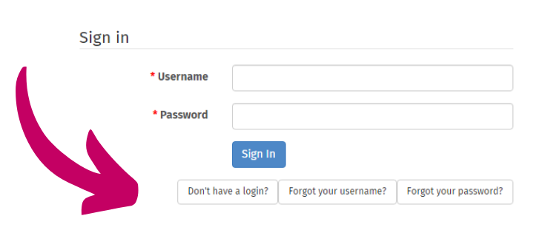
If you have any problems in accessing GO, talk to your Commissioner in the first instance who can check that the details you are using match what is already in the system.
Accessing the Learning Platform
Your GO username and password will not work on this platform, although the usernames are the same. To access the platform for the first time, follow these instructions.
- Follow the link to the Learning Platform. [Girlguiding: Log in to the site]
2. Click on the 'Forgot your password' link.  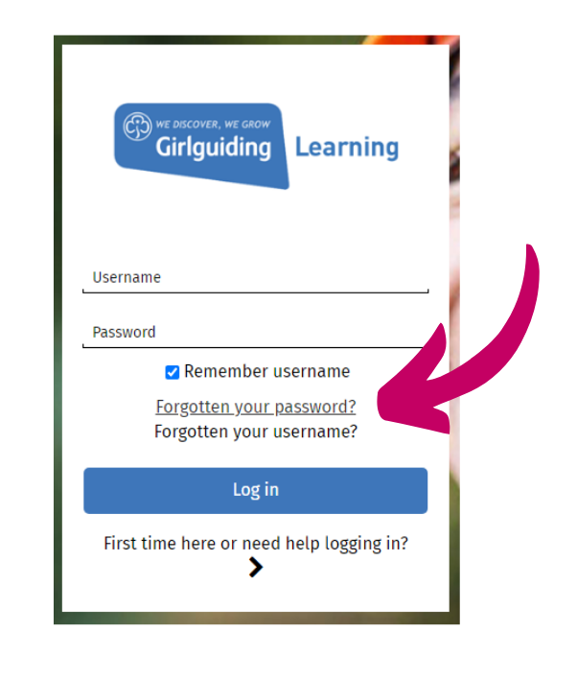 | 3. Enter your GO username and then click on the [Search] button.  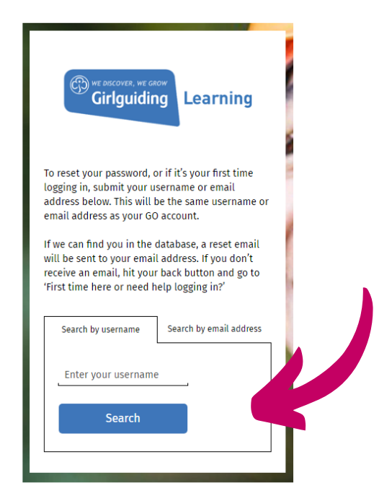

4. You should then receive the following message:
If you supplied a correct username or email address, then an email should have been sent to you containing instructions on resetting your password. Please check any spam/trash folders for this email if it’s not in your inbox.
If you have still not received this email, please contact us, our contact details are below.
MembershipSystems@girlguiding.org.uk
020 7834 6242
5. Check your email inbox for the email and follow the instructions within it.

