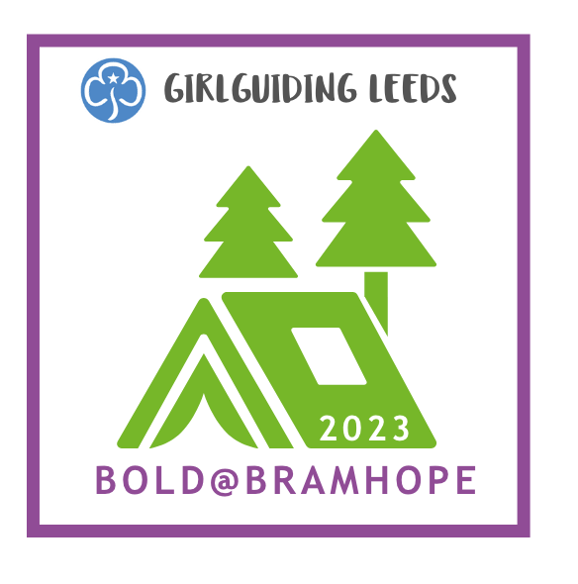
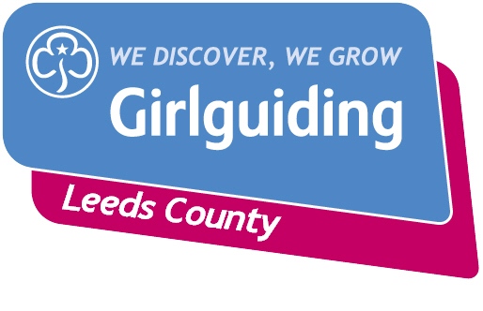

Bold @ Bramhope

What?
Leeds County Camp
Where?
Bramhope Scout Campsite
Who?
For Guides and Rangers
When?
26th – 29th May 2023
How much?
[insert cost] per Guide/Ranger

What else?

Guides and Rangers will camp with their own units but join with others from around the county to take part in two and a half days of activities plus evening entertainment. Activities on offer will include craft, wide game, music, geocaching, fires & cooking, fencing, archery and climbing plus many more.

A £25 non-refundable deposit will be required by [insert date] Please pay by [insert payment method].

Thank you

……………………………………………………………………………………………………………………………………………………………………………………………

Bold @ Bramhope

Guide/Ranger name ……………………………………………………………………………. would like to take part in Bold @ Bramhope on 26th to 29th May 2023. I have paid by [insert payment method choices].

I understand that once payment is made it will not be possible to obtain a refund.

I understand that further details will be provided when they become available.

Signed: ……………………………………………………………………………..
Print: ………………………………………………………………………………
Date: ………………………………………………………………………………

