**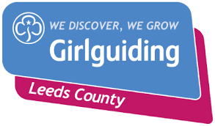****Commonwealth Award**

**Completed Form**

On completion of this form the badge and certificate will automatically be authorised and ordered for you.

|  |  |  |  |  |
| --- | --- | --- | --- | --- |
| **Member’s Full Name** |  | **Date of Birth** | | **/ /** |
| **Address:** |  | | | |
| **Date Completed** | Day Month Year | | | |
| **Unit** |  | | | |
| **Division** |  | | | |
| **Challenges Completed** |  | | | |
| **County Commissioner Visit** | Signed: | | Date | |
|  | Name: | |  | |

|  |
| --- |
| I certify that __________________________ (Name of member) has completed the challenges stated above and has met her personal goal to gain the Commonwealth Award. Please forward me the badge and certificate as soon as possible. |
| Leader Name __________________________________  Leader Signature _______________________________ Date / /  Leader Address to send  Badge & Certificate too |
| Please return this form to: Emma Forrester, Ranger Advisor  Email [rangeradviser@girlguidingleeds.org.uk](mailto:rangeradviser@girlguidingleeds.org.uk)  Date Received / / Date Badge Ordered / / |