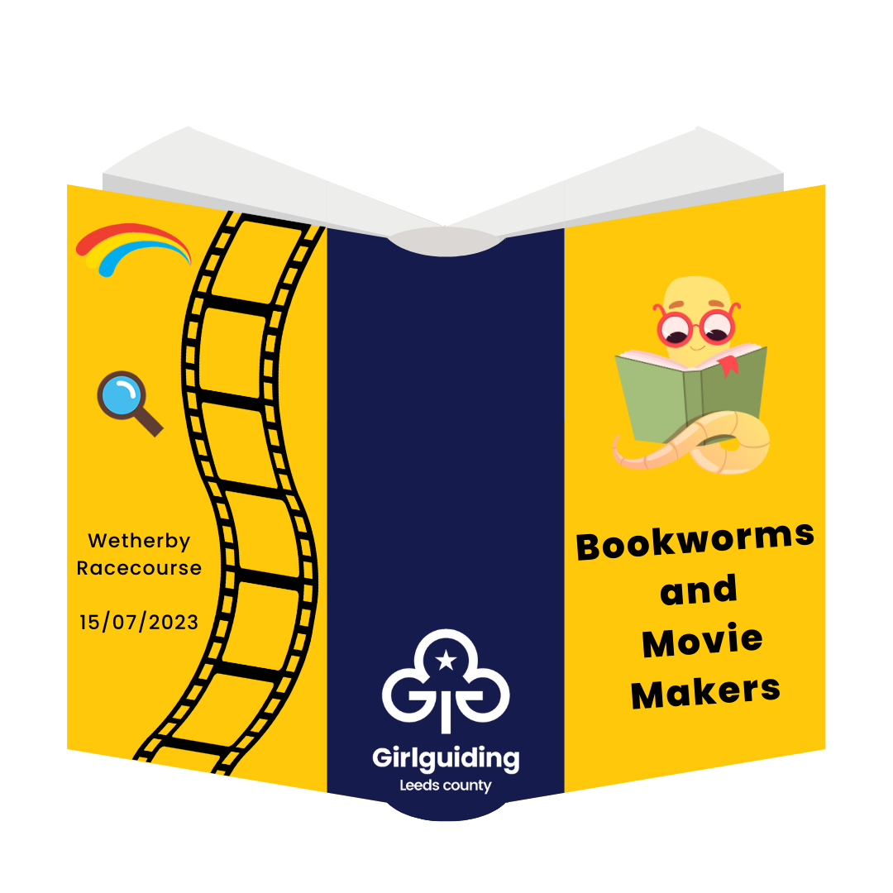

[insert the name of your unit]

Bookworms & Movie Makers
Activity Day – Saturday 15 July 2023 @ Wetherby Racecourse

Girlguiding Leeds has arranged a fun-filled activity day for rainbows and brownies to gather and enjoy together. The day will be centred around a theme of books and movies, and we will have a range of exciting activities available on the day for the rainbows and brownies to enjoy – from circus skills to lego, silent disco to dance classes, giant games to movie making, and much more!
The event will be held at Wetherby Racecourse on Saturday 15 July 2023, and will run from 10:00am until 4:30pm. This event is exclusively for rainbows and brownies across Leeds, and we are really looking forward to getting everyone together!
The event will cost [£17.50 increase this if you would like to include transport costs here as well] per rainbow or brownie. Your rainbow or brownie will also be required to bring a packed lunch and drink with them on the day.
To book a place at the event, please complete and return the reply slip below along with your £[17.50] payment.

Reply Slip

Name: ……………………………………………………………………………. would like to take part in:

 Bookworms & Movie Makers – on Saturday 15 July 2023.
£[17.50] payment is enclosed / transferred online (delete as appropriate)

We understand that once payment is made it will not be possible to obtain a refund.

Signed: …………………………………………………………………………….

Print: …………………………………………………………………………….

Date: …………………………………………………………………………….

Thank you

