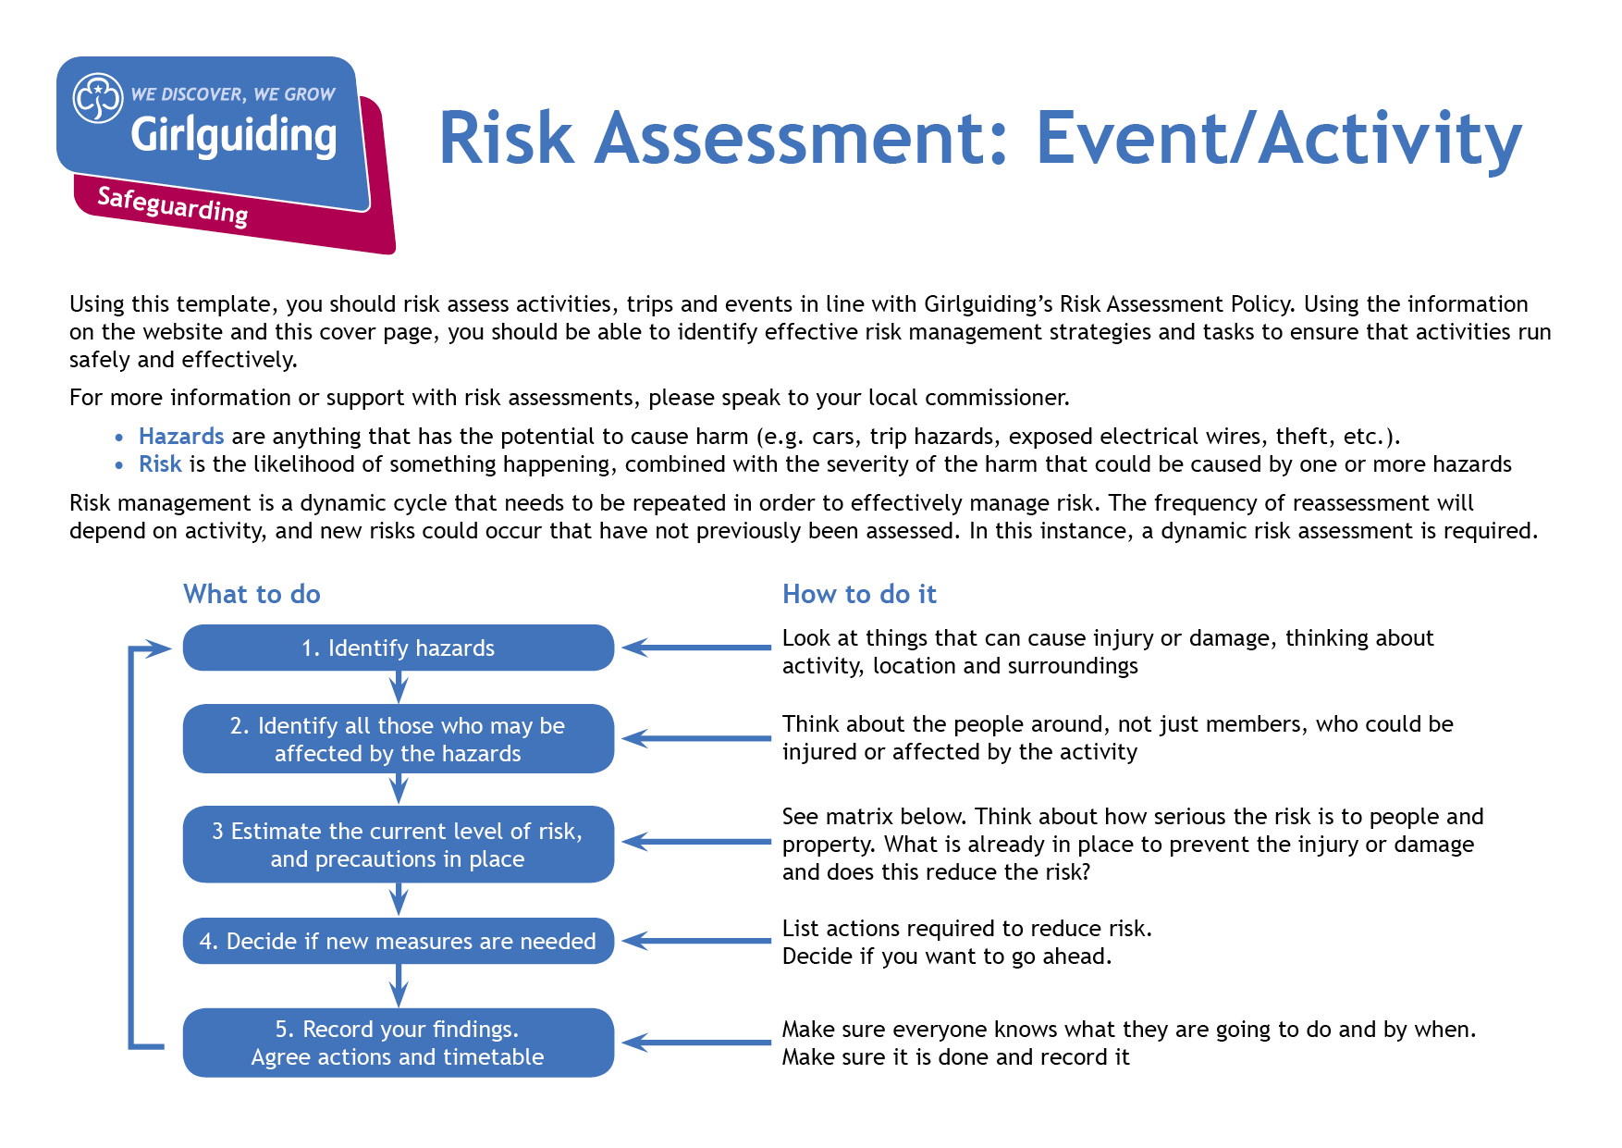`

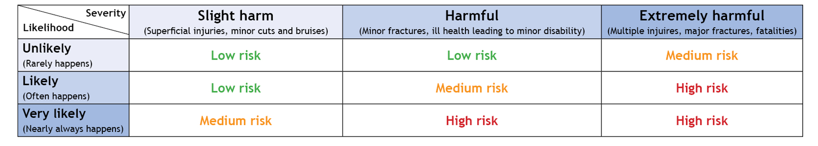

**Event information and risk assessment approval:**

|  |  |  |  |  |  |
| --- | --- | --- | --- | --- | --- |
| Event/Activity (brief description):  BOLD@BRAMHOPE COUNTY CAMP – Badge Workshop Activities | | | Date: 26 – 29 MAY 2023 | | |
| Leader in Charge: **CAROL BENNETT** | Total Attending:  349 | Adults:[1]  95 | Girls/Young women:  254 | | General Public: |
| Consent for Event/Activity forms completed: Yes  No  N/A | | | Venue: BRAMHOPECAMP SITE | | |
| Instructor qualification checked[2]*: Yes  No  N/A | | | | | |
| **Decision**: once all the actions are carried out can you eliminate or safely manage the risk of harm to ensure you can safely go ahead with this event/activity (i.e. have degree of challenge, harm and risk whilst being confident the control measures in place will keep girls safe). | | | | Yes  No | |
| If you answered ‘no’ to the above *decision* question, please explain why: | | | | | |
| Risk Assessment completed by: Carol Bennett | | | Role: Badge Workshop Lead | | |
| Has the risk assessment been shared with the leadership team? | | | | Yes  No | |
| Risk assessment due for review (must be within 12 months): | | | Date: March 2024 | | |

| **Hazards**  What could cause harm or damage? | **Who or what is at risk of being affected and how?** | **What are you already doing?**  How have you reduced the risk already? | **Likelihood of risk occurring**  **(L/M/H)** | **Severity of risk**  **(L/M/H)** | **Are further controls necessary?**  What else needs to happen to reduce the risk to an acceptable level? | **Action by:**  name/date |
| --- | --- | --- | --- | --- | --- | --- |
| **BADGE WORKSHOPS** | The Badge workshops will include Upcycling, Vlogging, Backwoods Cooking, Mixology, Guiding History, Personal Brand, Fitness, Natural Remedies, Whittling, Investigating, | | | | | |
| Tables and chairs/Benches (and other obstructions) | All participants | * Leaders and Young Leaders oversee setting up and moving tables and chairs/benches. * No one carries tables alone – at least two people carry each table. * Stack chairs facing side to the wall so they don’t fall. * Don’t stack chairs/benches more than six chairs/benches high. * Leaders help with stacking and unstacking chairs/benches. No one carries more than two chairs/one bench at a time. * Leaders set out tables and chairs/benches at the start of the activities, then push them against the walls until needed. | L | L |  | All |
| Craft items, scissors, etc. | Participants | * The items, components, and equipment being used or made should have low risks with the exception of those noted below | L | L |  | All |
| Glues and solvents (sharpie pens) – inhalation or injuries from mistakes or misuse | All present | * Ventilate the area appropriately during use and consider using outdoors if appropriate. · Follow the manufacturer’s guidance for use. * Collect leftover glue at the end of the activity. * Adults or Young Leaders supervise young people when they’re using solvents and glues – at least one adult or Young Leader for each group. · Leaders brief young people on using the chemicals safely before use. | M | L |  | All |
| Participant behaviour exposes group to danger or injury | All participants | * Participants reminded of behaviour expectations before the event via parental email * Participants reminded of behaviour expectations at the start of the event * Leaders to monitor behaviour and issue reminders as necessary during the event Leaders to stop the event if behaviour becomes a danger to others. | M | L |  | All |
| **BACKWOODS COOKING** |  |  |  |  |  |  |
| Fire | Risk of fire spreading, risk of burns to participants | Fires to be lit in campfire circle designed for this use | L | H | Bucket of water present to put out any fire spreading off fire base and to be used for initial treatment of burns.  Adult supervision throughout to ensure sensible behaviour and to encourage placing sticks on the fire rather than throwing them.  All fires to be kept to a small size and spaced around fire base if more than one group lighting at once.  Long hair to be tied back and any dangling clothing removed or tucked in(and placed on benches out of the way if removed).  Fire base area to be kept clear.  Fires not to be left unattended and to be carefully put out at the end of each session. | Leaders with group and activity during sessions |
| Wet Weather | Increased difficulty for successful fire lighting. | Cotton wool and dry kindling to be split into sets for each session and stored in plastic containers to keep dry until needed. | L | L | In the event of wet weather, small amounts of lighting material to be given out at once while the rest kept in containers. | Leaders with group and activity during sessions |
| Fear of lighting fire | Likely to be those who haven’t previously done it or who have had a bad experience. | Groups to be accompanied by a leader | L | L | Leaders to demonstrate safe techniques including lighting away from yourself rather than towards yourself and to talk through the risks. Leaders to encourage having a go where possible but to allow people not to if they don’t want to. | Leaders with group and activity during sessions |
| Food allergies, dietary requirements, food hygiene and consuming hot food. | Those who have allergies at risk of allergic reaction, risk of dietary requirements not being met, risk of food poisoning, risk of burns to mouth or from dripping. | Any allergies will be listed on wrist bands, alternative options supplied to meet dietary requirements. No high risk ingredients being used (noodles, pitta pizza and dampers). Ingredients to be kept separate to avoid cross contamination. | L | L | Leaders to check for any allergies / dietary requirements before distributing. Minimal handling of food to be encouraged. Each participant only to handle own food. Reminders not to put hot food straight in mouth and to hold food so that any drips don’t land on bare skin. | Leaders with group and activity during sessions |
| Sticks for Dampers | Risk of injury from sharp point | Wooden sticks to be used covered in foil | L | L | Leader supervision to ensure sensible behaviour and suitable spacing around fire to minimize risk of catching each other with sticks. | Leaders with group and activity during sessions |
| Burns | Cooking in a can or retrieving food cooking in the embers | Can to be modified with a handle and pan holders/Fire glove to be supplied. Tongs to be used to retrieve food from embers. Bucket of water available to treat burns. First Aid kit available. | L | M | Leader supervision to ensure sensible behaviour | Leaders with group and activity during sessions |
| Smoke | Anyone with a health condition such as Asthma | Check first aid information on health form, bring inhaler. Sit further away from the fire if necessary. | L | M |  | Leaders with group and activity during sessions |
| Slips, Trips, Falls | All participants | Area to be kept clear. Any tree roots to be pointed out at the start of the activity | L | L |  |  |
| **WHITTLING** |  |  |  |  |  |  |
| Knife cuts | Risk of cuts from using a whittling knife | Leather apron to be worn to protect the body. | L | M | Small groups to undertake this activity  Safety talk provided at the beginning of the activity.  Demonstration on how to use the knife, with movement away from the body.  Adult supervision throughout to ensure sensible behavior. | Leaders with group and activity during sessions |
| **MIXOLOGY** |  |  |  |  |  |  |
| Food allergies | Participants | All girls to wear a wristband highlighting any food allergies  Ingredients of drinks clearly identified to participants  Packaging available for ingredients available for | L | L |  | Leaders with group and activity during sessions |
| **UPCYCLING & HISTORY OF GUIDING** |  |  |  |  |  |  |
| Needles & Pins | Participants receiving stick pin injuries from using needles & pins | Participants to be made aware of the danger and to proceed carefully. | L | L |  |  |

1. Adult refers to adult volunteers who are part of the event/activity delivery team
2.  Refer to the Activities Finder for information about instructor qualifications