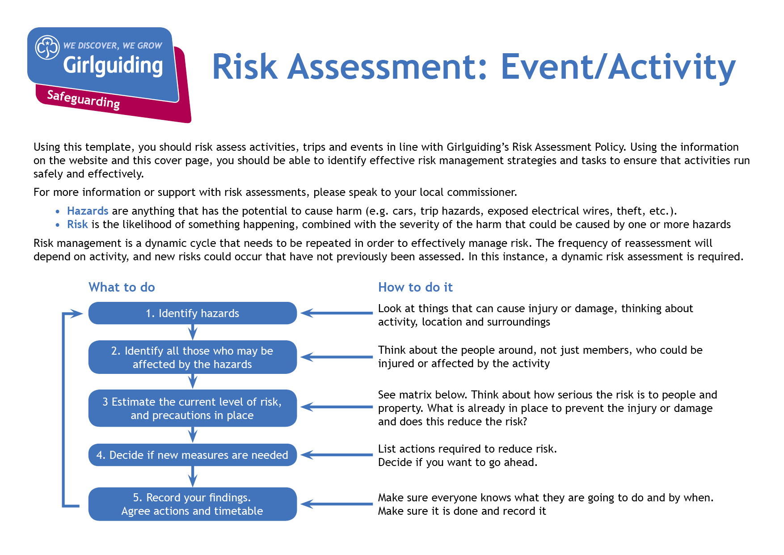`

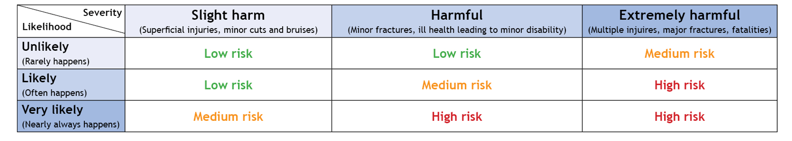

**Event information and risk assessment approval:**

|  |  |  |  |  |  |
| --- | --- | --- | --- | --- | --- |
| Event/Activity (brief description):  BOLD@BRAMHOPE COUNTY CAMP – CRAFT ACTIVITIES | | | Date: 26 – 29 MAY 2023 | | |
| Leader in Charge: **CAROL BENNETT** | Total Attending:  349 | Adults:[1]  95 | Girls/Young women:  254 | | General Public: |
| Consent for Event/Activity forms completed: Yes  No  N/A | | | Venue: BRAMHOPECAMP SITE | | |
| Instructor qualification checked[2]*: Yes  No  N/A | | | | | |
| **Decision**: once all the actions are carried out can you eliminate or safely manage the risk of harm to ensure you can safely go ahead with this event/activity (i.e. have degree of challenge, harm and risk whilst being confident the control measures in place will keep girls safe). | | | | Yes  No | |
| If you answered ‘no’ to the above *decision* question, please explain why: | | | | | |
| Risk Assessment completed by: LOUISE FLYNN | | | Role: CRAFT ACTIVITY LEAD | | |
| Has the risk assessment been shared with the leadership team? | | | | Yes  No | |
| Risk assessment due for review (must be within 12 months): | | | Date: | | |

| **Hazards**  What could cause harm or damage? | **Who or what is at risk of being affected and how?** | **What are you already doing?**  How have you reduced the risk already? | **Likelihood of risk occurring**  **(L/M/H)** | **Severity of risk**  **(L/M/H)** | **Are further controls necessary?**  What else needs to happen to reduce the risk to an acceptable level? | **Action by:**  name/date |
| --- | --- | --- | --- | --- | --- | --- |
| **GENERAL CRAFTS** |  |  |  |  |  |  |
| Tables and chairs (and other obstructions | All participants | Leaders and Young Leaders oversee setting up and moving tables and chairs.  No one carries tables alone – at least two people carry each table.  Stack chairs facing side to the wall so they don’t fall.  Don’t stack chairs more than six chairs high.  Leaders help with stacking and unstacking chairs. No one carries more than two chairs at a time.  Leaders set out tables and chairs at the start of the activities, then push them against the walls until needed. | L | L |  | All |
| Craft items, scissors, etc. | Participants | The items, components, and equipment being used or made should have low risks with the exception of those noted below | L | L |  | All |
| Glues and solvents (sharpie pens) – inhalation or injuries from mistakes or misuse | All present | Ventilate the area appropriately during use and consider using outdoors if appropriate. · Follow the manufacturer’s guidance for use.  Collect leftover glue at the end of the activity.  Adults or Young Leaders supervise young people when they’re using solvents and glues – at least one adult or Young Leader for each group. · Leaders brief young people on using the chemicals safely before use. | M | L |  | All |
| Participant behaviour exposes group to danger or injury | All participants | Participants reminded of behaviour expectations before the event via parental email  Participants reminded of behaviour expectations at the start of the event  Leaders to monitor behaviour and issue reminders as necessary during the event Leaders to stop the event if behaviour becomes a danger to others. | M | L |  | All |
| **PYROGRAPHY** |  |  |  |  |  |  |
| Work space | Participants and leaders | Ensure there is a tidy work surface, make sure the area working in is well ventilated and wear the safety gloves provided. | M | L |  | All |
| Pen stands | Participants and leaders | Tape the stand down onto the work surface to ensure it can’t slide about or fall over. | M | L |  | All |
| Minor Burns | Participants | Heat resistant gloves to be worn when using/around the pyrography pens.  Pyrography pens to be put in stands provided whenever not in hand.  Pyrography pens never put down directly onto table.  Sink and cold water for first aid. | M | L |  | All |
| Heat sources – burns from mistakes or misuse. | All participants | Demonstration of pyrography pens provided by leaders.  Adults or Young Leaders supervise young people when they’re using hot items (such as glue guns, and pyrography pens) – at least one adult or Young Leader for each group. · Use heat sources in a defined area to restrict access.  Leaders brief young people on using the heat sources safely before they use them. | M | L |  | All |
| Fire | Participants  Building | Pyrography pens to be put in stands provided whenever not in hand  Pyrography pens never put down directly onto table.  Prolonged pressure on wood discs could lead to fire – instructions to participants needs to be clear about this.  Water to be available to extinguish any fire. | M | L | Ensure clear instructions are provided to participants and their leaders. | All |
| Pyrography pens – set up | All participants | Before pyrography pens are switched on for the day ensure that the tip is inserted and secured correctly.  Never try to insert or change nibs when the tool is hot or connected to a power source. If you’re unsure if a tip has cooled down completely you can quickly dab it on a damp sponge – if it sizzles or hisses then it’s still hot.  Wait for the nib to completely cool down first before changing the nib, although participants can rotate around the pens provided to use a different type of nib. | M | L |  | All |
| Electricity / Electric shock | All participants | Mains powered portable equipment protected by RCD to distribution board, wall socket or lead. · Sufficient outlets to support the range of equipment normally used without resorting to regular use of multi-socket adaptors. · Regular checks of cables etc. for frays | M | L |  | All |
| **GLASS ETCHING** |  |  |  |  |  |  |
| Dust | All participants | Masks to be worn and protective eye wear.  Damp cloth to wipe away dust from the glass and tables when finished. | L | L |  | All |
| Replacing batteries | All participants | Batteries leak or are inserted incorrectly.  Recycling bag to be available for used batteries, which can be disposed of at a recycling point at the local tip, or office collection point.  Wash hands thoroughly with soap and water immediately if battery acid comes into contact with skin.  Wear gloves if handling batteries. | L | L |  | All |
| Broken glass product | All participants | Glass to be etched is dropped and breaks. Leader to supervise cleaning up of the area.  Dust pan and brush to be to hand, together with a suitable bucket to put the broken glass.  Glass to be disposed of at a recycling point after the event. | M | L |  | All |
| **BADGE MACHINE** |  |  |  |  |  |  |
| Fingers trapped in machine | Participants and leaders | Brief group, adequate supervision provided by group leader(s) | L | L |  | All |
| Stabbed by badge pins | Participants and leaders | Brief group, adequate supervision provided by group leader(s) | L | L |  | All |
| **RAG WREATHS** |  |  |  |  |  |  |
| Sharp welds on metal rings | Participants | Participants to be made aware that there may be sharp edges on the rings.  Glue has been applied to the weld joints; however, they may remain sharp | M | L |  | All |
| **TIN LANTERNS** |  |  |  |  |  |  |
| Tins will have been frozen so they don’t squash when punching | Participants  Fingers sticking to the tin, slipping when punching holes | Thin gloves to be worn when first handling tin cans.  Cans to be placed on towel to prevent slipping. | M | M | Ask participants to advise in towels are excessively wet | All |
| Hammering nails to make the design on the tin  Puncture injury from nails/pins | Participants  Adults to a lesser extent  Hammering fingers and thumbs | To explain to the participants how to safely hammer the nails into the tin. Hold the nails at the bottom and keep fingers away from the hammer. | M | M |  | All |
| Sharp edges where the nails have made a hole (likely to be inside the tin) | Participants  Adults to a lesser extent  Cut fingers and hands from any sharp edges | Hold the tins from the bottom. | L | M | Tell the participants not to put their hands or fingers inside the tin | All |
| Hole punch | All participants | Demonstration of the correct use of hole punch.  Leaders to supervise | M | L |  | All |
| Sharp edges on tins – cuts | All participants | Edges of cans to be rolled ahead of the event to remove sharp edge where tin lid has been removed. | H | L |  | All |
| Sharp edges where tin has been punctured. | All participants | Participants to be warned of dangers from cut cans and to be supervised during activity | M | M |  | All |
| Melting the ice using warm water | All participants  Water too hot | Tell the Rangers they only need to use warm water. | L | M | Run a bowl or sink with warm water and stand the tin in to melt the ice. | All |
| Lighting the tin with a tea light | All participants  Adults to a lesser extent  Burning fingers when lighting the tea light.  Risk of fire | Reiterate the risks and dangers of tea lights with the participants and ensure adult supervision at all times | M | H | Use battery operated tea lights | All |

1. Adult refers to adult volunteers who are part of the event/activity delivery team
2. * Refer to the Activities Finder for information about instructor qualifications