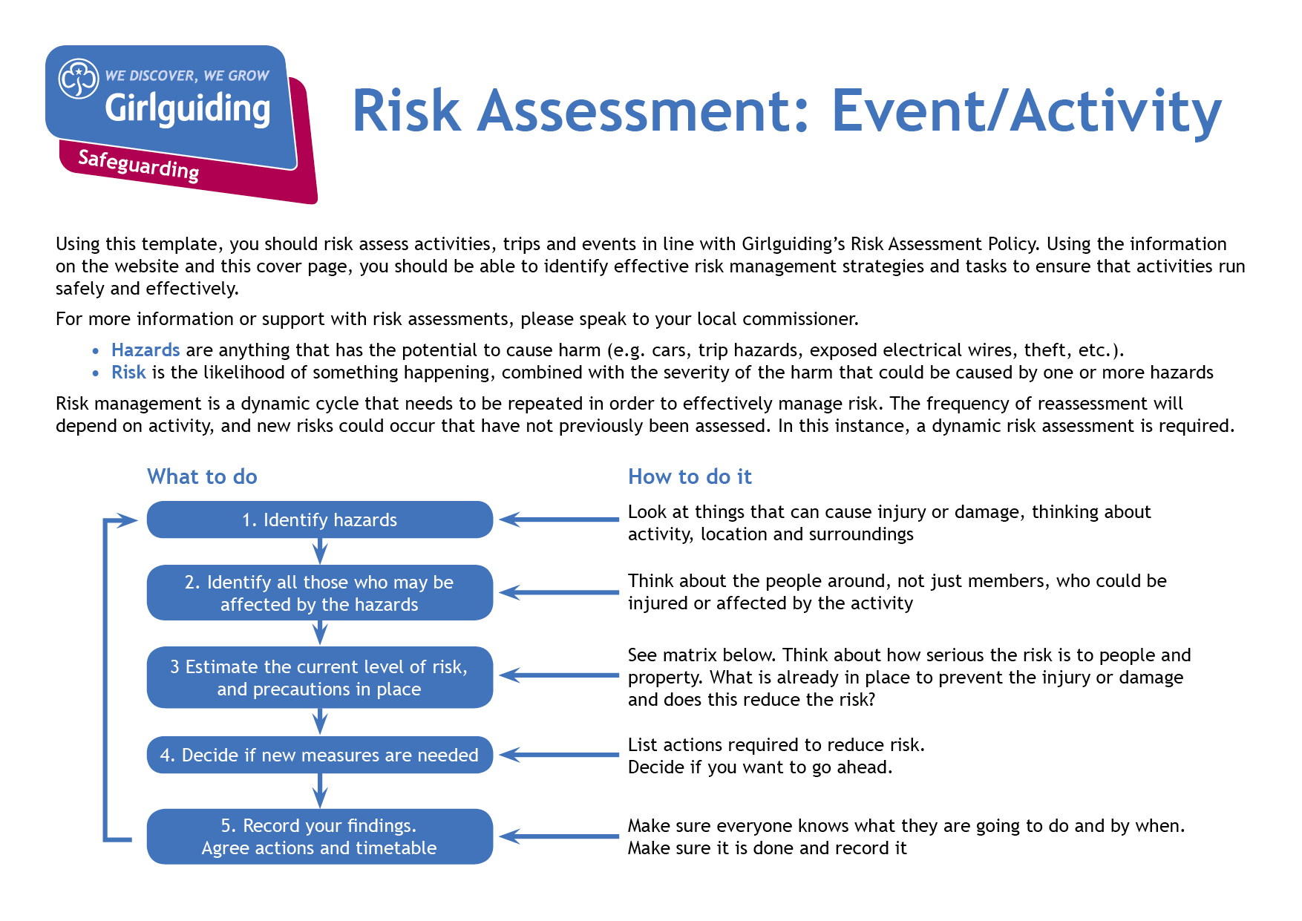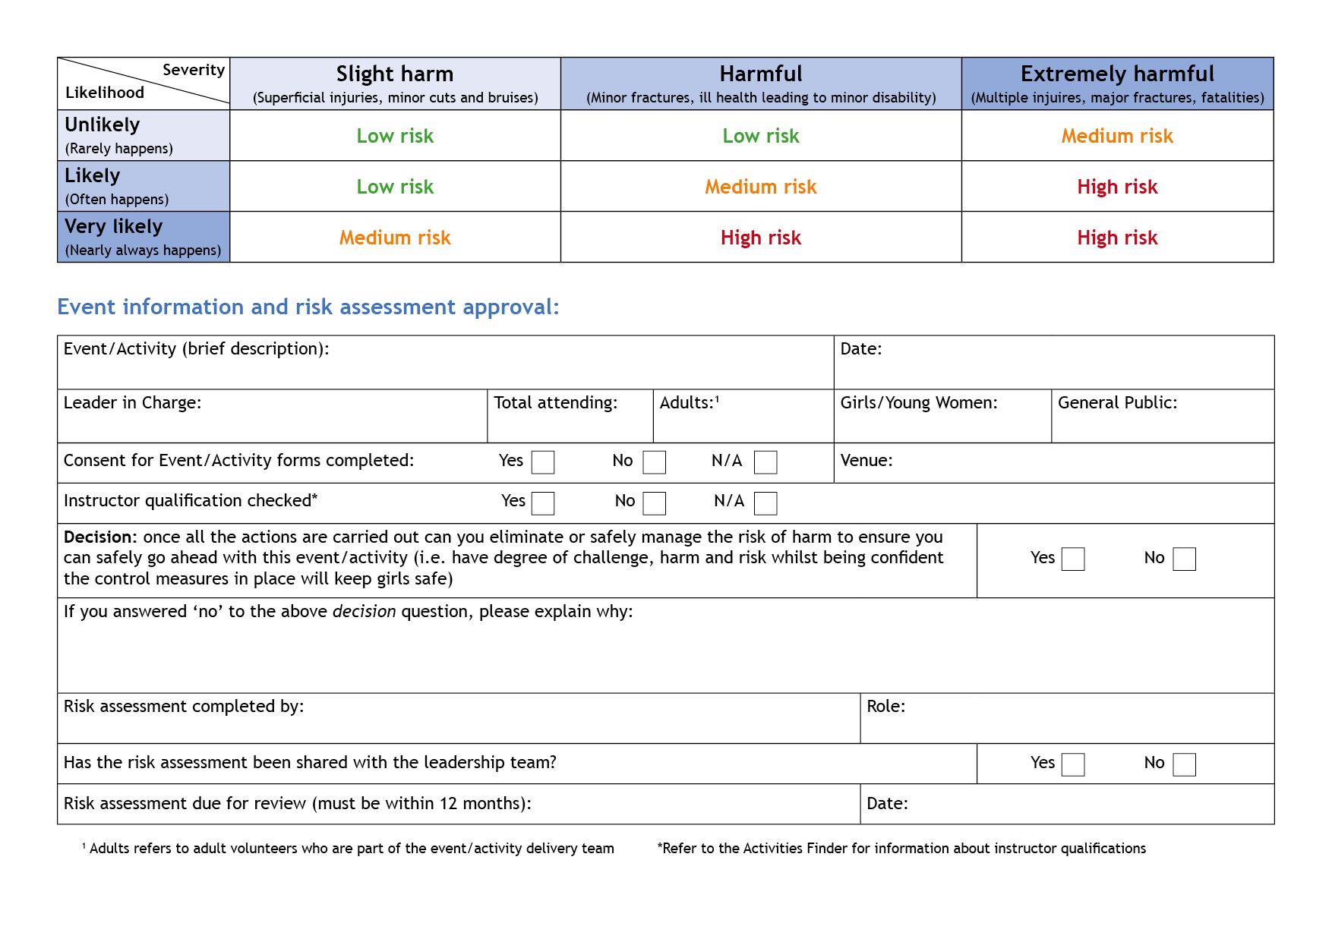

Camp Activity Lead

Anne Esslemont

y

Y

y

Before repeating activity

Bramhope Scout Campsite

13

At least 1

Max 12

Anne Esslemont

None

27th and 28th May 2023

Frisbee Golf & Croquet

| **Hazards**  What could cause harm or damage? | **Who or what is at risk of being affected and how?** | **What are you already doing?**  How have you reduced the risk already? | **Likelihood of risk occurring**  **(L/M/H)** | **Severity of risk**  **(L/M/H)** | **Are further controls necessary?**  What else needs to happen to reduce the risk to an acceptable level? | **Action by:**  name/date |
| --- | --- | --- | --- | --- | --- | --- |
| Croquet Hoops | Trip hazard for participants and those in the area | Allocated a space in a large open area | L | L | Hoops only to be positioned when a group are ready to play. Playing area to be chosen to be away from other activities going on at the same time and routes where passers by are likely to be walking.  All participants to be aware of game layout.  Leader supervision of playing area. | Leaders with group and in activity zone |
| Croquet balls | Balls could cause damage to property or injury to people | Allocated a space in a large open area away from car park | L | L | Participants to be briefed that the balls should be hit with the mallet along the ground and not thrown or kicked.  Leader supervision for sensible behaviour. | Leaders with group and in activity zone |
| Croquet mallets | Mallets at risk of damage and risk of injury if not used sensibly. |  | L | L | Leader supervision for sensible behaviour. Participants to be briefed to use the round end to hit the ball along the ground and not to wave the mallet in the air. | Leaders with group and in activity zone |
| Frisbees | Frisbees could cause damage to property or injury to people | Allocated a space in a large open area away from car park | L | L | Targets to be positioned away from other activities and so there is nothing beyond them which is likely to be damaged if frisbees go too far. Participants to be aware of when frisbees are being thrown.  Leader supervision for sensible behaviour. | Leaders with group and in activity zone |

| **Hazards**  What could cause harm or damage? | **Who or what is at risk of being affected and how?** | **What are you already doing?**  How have you reduced the risk already? | **Likelihood of risk occurring**  **(L/M/H)** | **Severity of risk**  **(L/M/H)** | **Are further controls necessary?**  What else needs to happen to reduce the risk to an acceptable level? | **Action by:**  name/date |
| --- | --- | --- | --- | --- | --- | --- |
|  |  |  |  |  |  |  |
|  |  |  |  |  |  |  |
|  |  |  |  |  |  |  |
|  |  |  |  |  |  |  |
|  |  |  |  |  |  |  |
|  |  |  |  |  |  |  |
|  |  |  |  |  |  |  |
|  |  |  |  |  |  |  |