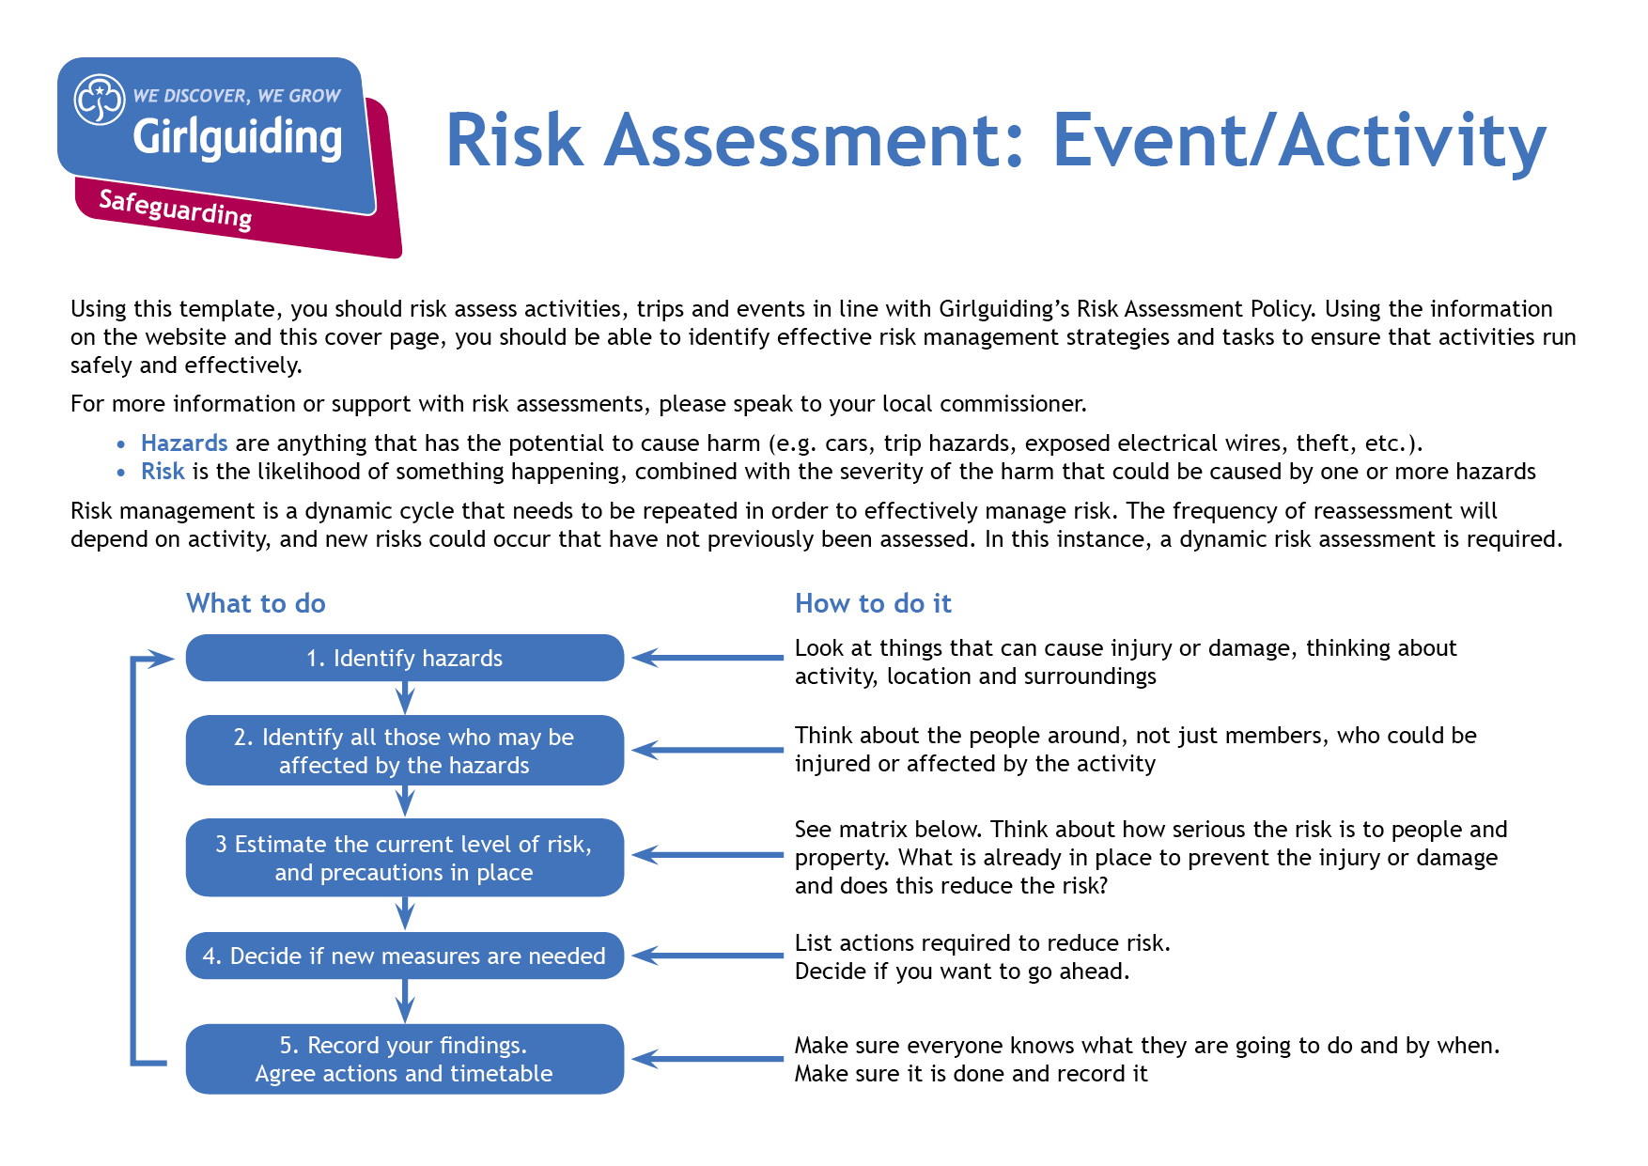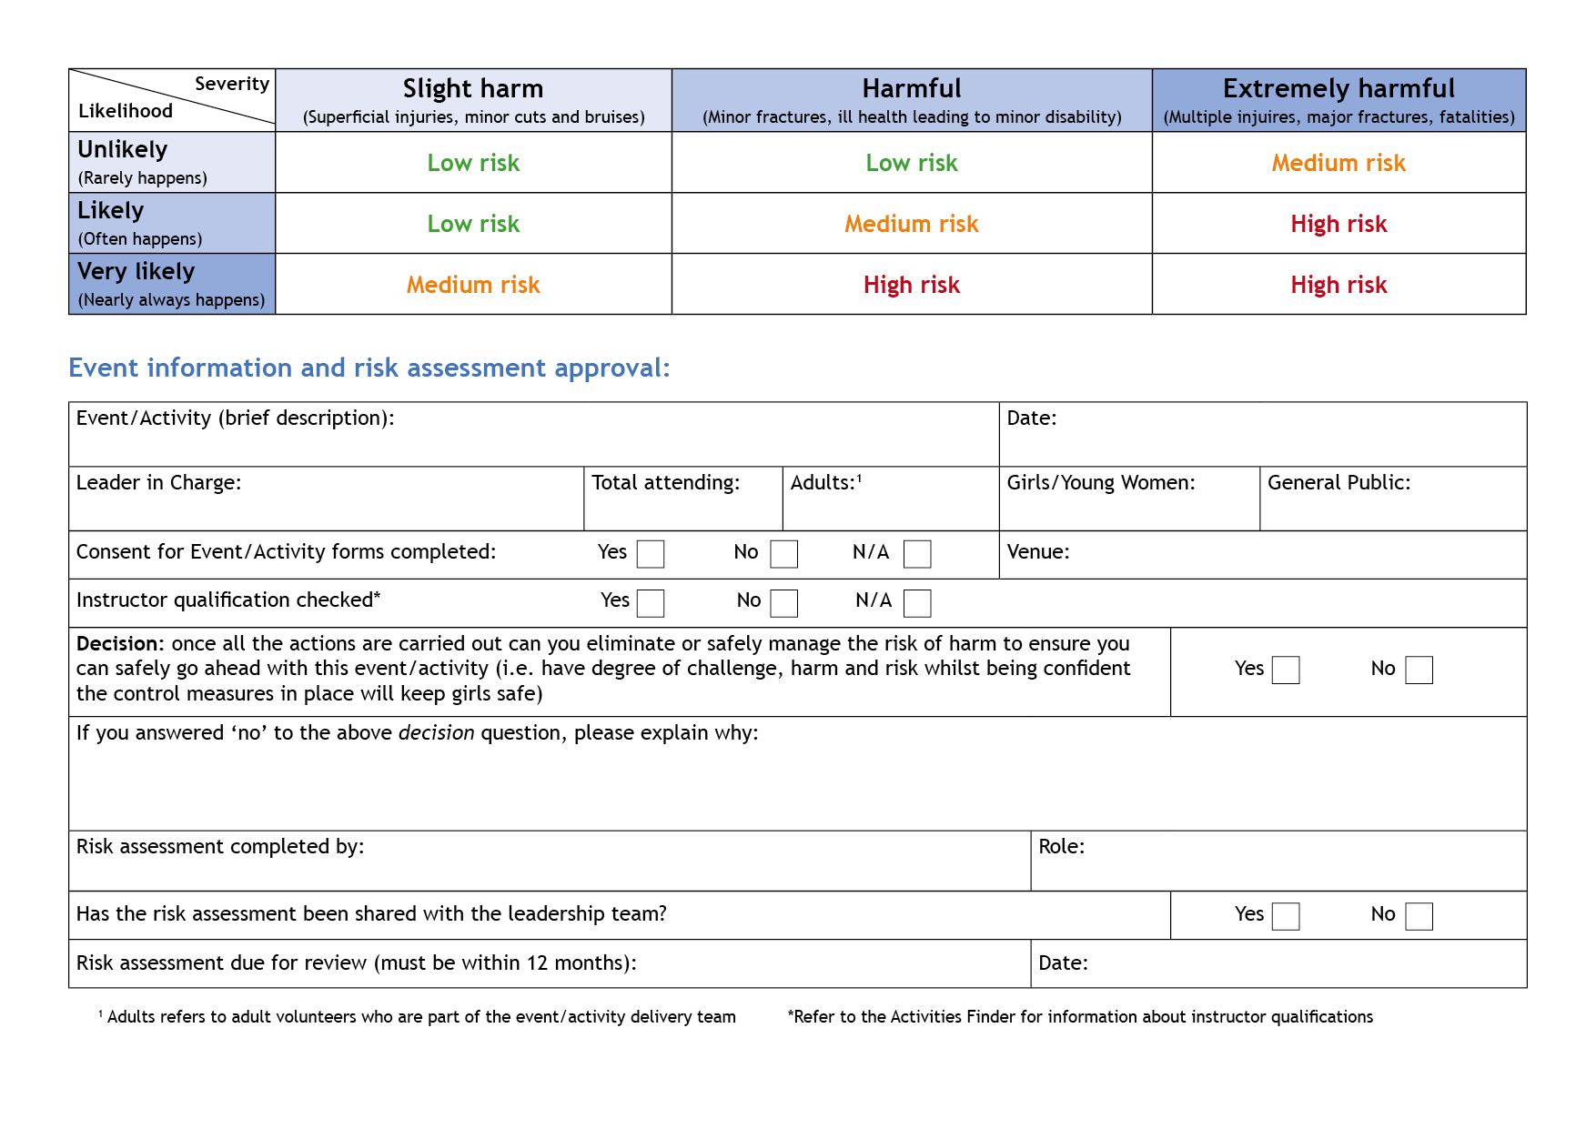

Camp Activity Lead

Anne Esslemont

y

Y

y

Before repeating activity

Bramhope Scout Campsite

13

At least 1

12

Anne Esslemont

None

27th and 28th May 2023

Geocaching

| **Hazards**  What could cause harm or damage? | **Who or what is at risk of being affected and how?** | **What are you already doing?**  How have you reduced the risk already? | **Likelihood of risk occurring**  **(L/M/H)** | **Severity of risk**  **(L/M/H)** | **Are further controls necessary?**  What else needs to happen to reduce the risk to an acceptable level? | **Action by:**  name/date |
| --- | --- | --- | --- | --- | --- | --- |
| Moving around site | Disruption to other activities / camping areas |  | L | L | Caches to be sited away from other activities that are likely to cause a risk (e.g. fires, archery etc) and tents.  Groups to be briefed on where they can and can’t go. | JB when setting caches.  Leaders with group / in activity zone |
| Crossing car park / driveway | Participants at risk from moving vehicles | Vehicle movement planned to be minimal during activity times | L | L | Caches to be sited away from car park and driveway.  Groups to be briefed to be aware of moving vehicles when crossing car parks and driveway. | JB when setting caches.  Leaders with group / in activity zone |
| Unable to find caches / use GPS units | Participants at risk of disappointment |  | L | L | Appropriate level of difficulty when setting caches and briefing on what they’re looking for.  Clear instructions to be given on use of GPS units.  Group to know where to find a leader to ask for help if needed. | JB when setting caches.  Leaders with group / in activity zone |
|  |  |  |  |  |  |  |
|  |  |  |  |  |  |  |

| **Hazards**  What could cause harm or damage? | **Who or what is at risk of being affected and how?** | **What are you already doing?**  How have you reduced the risk already? | **Likelihood of risk occurring**  **(L/M/H)** | **Severity of risk**  **(L/M/H)** | **Are further controls necessary?**  What else needs to happen to reduce the risk to an acceptable level? | **Action by:**  name/date |
| --- | --- | --- | --- | --- | --- | --- |
|  |  |  |  |  |  |  |
|  |  |  |  |  |  |  |
|  |  |  |  |  |  |  |
|  |  |  |  |  |  |  |
|  |  |  |  |  |  |  |
|  |  |  |  |  |  |  |
|  |  |  |  |  |  |  |
|  |  |  |  |  |  |  |