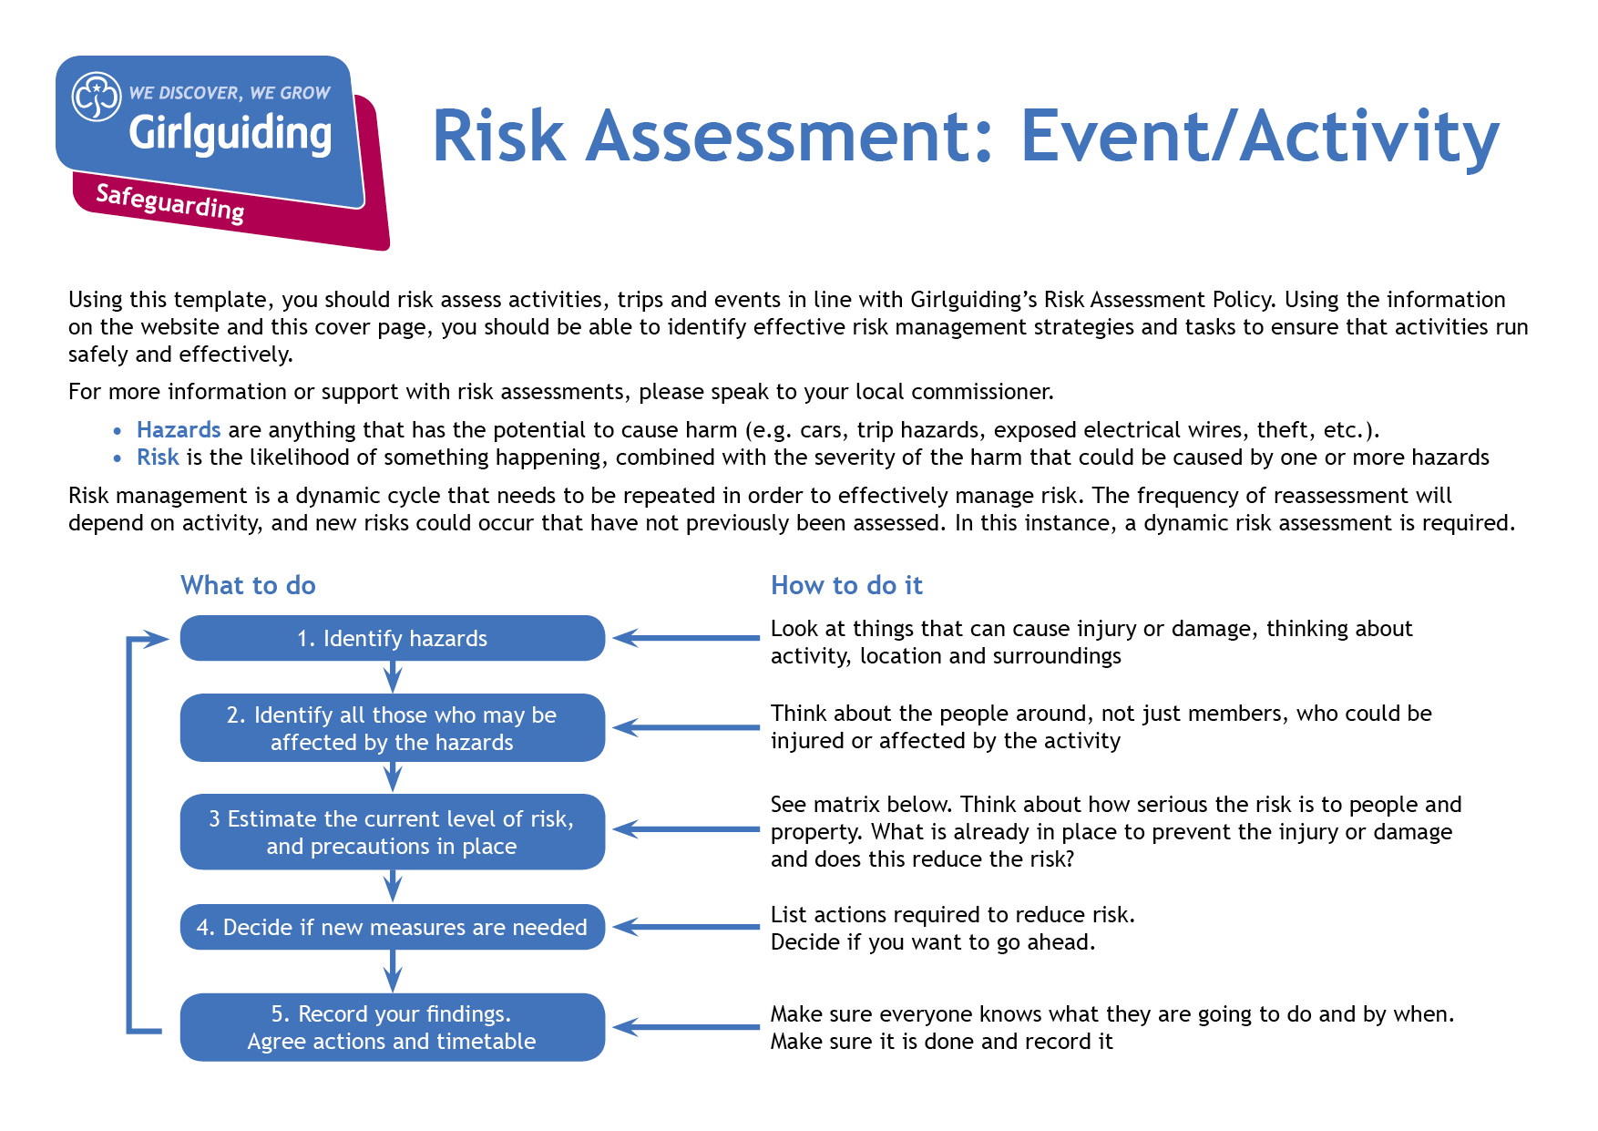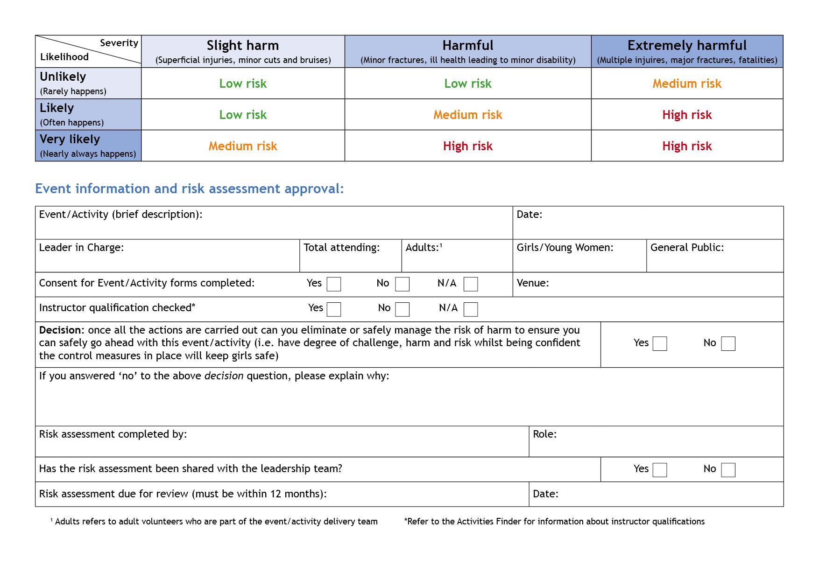

Camp Activity Lead

Anne Esslemont

y

Y

y

Before repeating activity

Bramhope Scout Campsite

7

At least 1

Max 6

Anne Esslemont

None

27th and 28th May 2023

Indoor cooking

| **Hazards**  What could cause harm or damage? | **Who or what is at risk of being affected and how?** | **What are you already doing?**  How have you reduced the risk already? | **Likelihood of risk occurring**  **(L/M/H)** | **Severity of risk**  **(L/M/H)** | **Are further controls necessary?**  What else needs to happen to reduce the risk to an acceptable level? | **Action by:**  name/date |
| --- | --- | --- | --- | --- | --- | --- |
| Poor food hygiene | All those eating the food prepared at risk of food poisoning | No high risk ingredients to be used, suitable equipment and cleaning materials provided | L | L | Hand wash sink to be used to wash hands with soap and hot water before starting and during activity as needed.  Long hair to be tied back.  Utensils to be washed up between each group and surfaces to be cleaned. | Leaders with group / in activity zone |
| Allergies | Those who suffer at risk of allergic reaction | Details of allergies to be collected in advance and appropriate alternatives provided. Those with allergies to have details on wrist bands.  No nuts to be used. | L | H | Ingredients to be kept separate and separate set(s) of utensils available for use when needed. | Leaders with group / in activity zone |
| Burns | Those in kitchen at risk of burns from hot baking trays and oven | Using kitchen with plenty of space available. Oven gloves to be provided. | L | L | Leader supervision to ensure sensible behaviour and no crowding around oven. Oven gloves used to handle hot trays which should then be placed on suitable surface. | Leaders with group / in activity zone |
| Running out of ingredients | Participants at risk of disappointment | Ingredients to be split for separate sessions with some spare | L | L | Leader supervision to ensure each group only make one batch and to minimize waste. | Leaders with group / in activity zone |
|  |  |  |  |  |  |  |

| **Hazards**  What could cause harm or damage? | **Who or what is at risk of being affected and how?** | **What are you already doing?**  How have you reduced the risk already? | **Likelihood of risk occurring**  **(L/M/H)** | **Severity of risk**  **(L/M/H)** | **Are further controls necessary?**  What else needs to happen to reduce the risk to an acceptable level? | **Action by:**  name/date |
| --- | --- | --- | --- | --- | --- | --- |
|  |  |  |  |  |  |  |
|  |  |  |  |  |  |  |
|  |  |  |  |  |  |  |
|  |  |  |  |  |  |  |
|  |  |  |  |  |  |  |
|  |  |  |  |  |  |  |
|  |  |  |  |  |  |  |
|  |  |  |  |  |  |  |