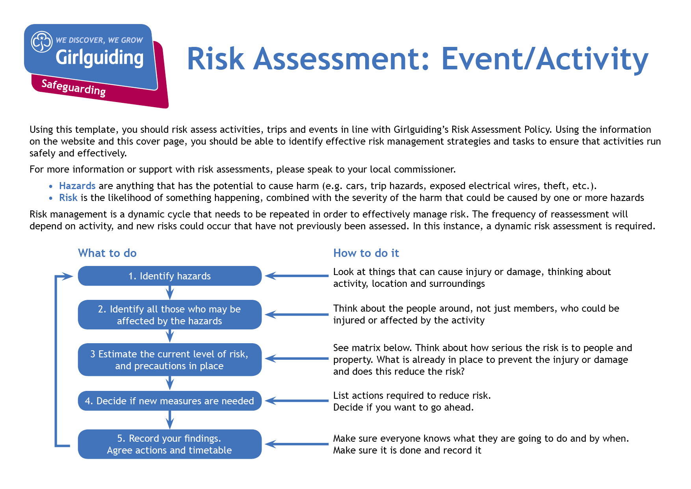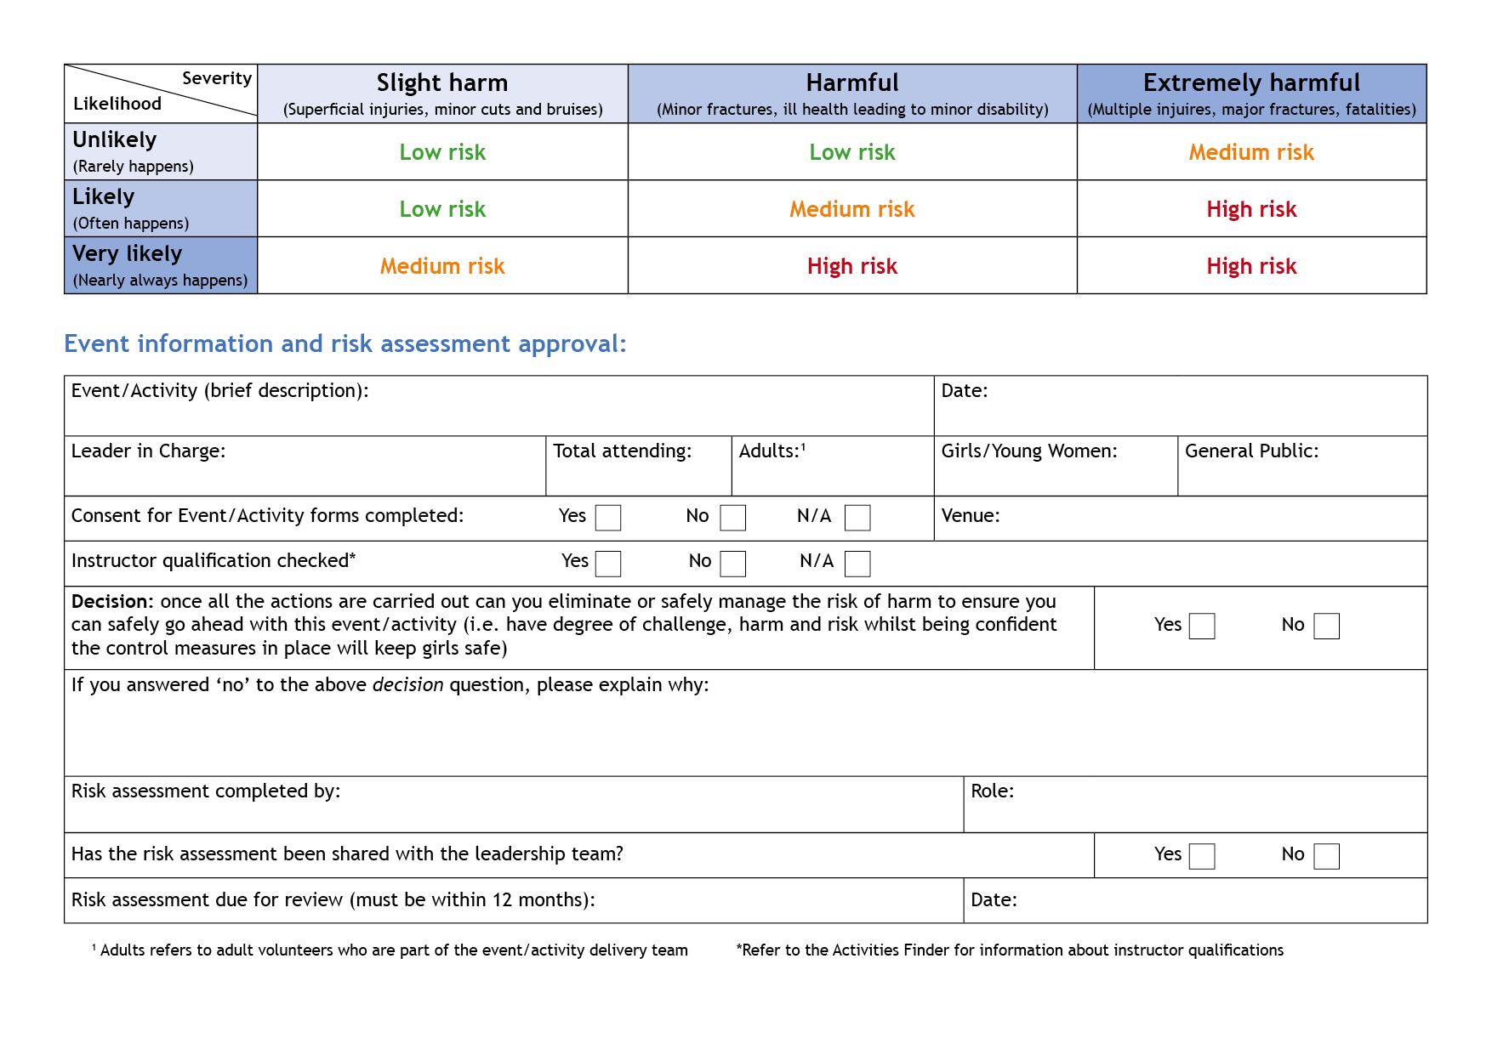

Activity Lead

Anne Esslemont

Y

y

y

Before next camp

Bramhope Griddlery

17

2

15

Anne Esslemont

0

27th & 28th May 2023

Outdoor Cooking

| **Hazards**  What could cause harm or damage? | **Who or what is at risk of being affected and how?** | **What are you already doing?**  How have you reduced the risk already? | **Likelihood of risk occurring**  **(L/M/H)** | **Severity of risk**  **(L/M/H)** | **Are further controls necessary?**  What else needs to happen to reduce the risk to an acceptable level? | **Action by:**  name/date |
| --- | --- | --- | --- | --- | --- | --- |
| Burns from fire / handling hot items | All participants and those in vicinity at risk of minor or major burns | Using area designed for fires. Participants advised to have long hair tied back, no shorts, closed toed shoes | L | H | Bucket of water to be available for immediate treatment of any burns and dealing with fire spreading to places it shouldn’t, oven gloves & tongs available for removing hot items from fire, leaders to supervise for sensible behaviour & not crowding around fire | Activity & group leader during session |
| Smoke | All at risk of breathing in smoke & getting smoke in eyes, particular risk to those with asthma or other breathing difficulties | Wrist bands to be worn identifying those with medical conditions | L | H | Check that any asthmatics have inhalers with them, limit time spent in smoke as far as possible, discourage from rubbing eyes | Activity & group leader during session |
| Slips, trips & falls | All in vicinity at risk of minor to major injury |  | L | H | Keep area clear of trip hazards, check that shoes are properly fastened, brief group to take extra care around fire, no running or crowding round | Activity & group leader during session |
| Fire getting out of control | People & property at risk of fire damage | Using area designed for fires – contained to minimize the risk of spreading | L | H | Filled fire bucket on hand, ensure fire kept to a manageable size | Activity & group leader during session |
| Splinters | All handling wood at risk |  | L | L | Suitable wood to be chosen to minimize risk of splinters and care taken when handling | Activity & group leader during session |

| **Hazards**  What could cause harm or damage? | **Who or what is at risk of being affected and how?** | **What are you already doing?**  How have you reduced the risk already? | **Likelihood of risk occurring**  **(L/M/H)** | **Severity of risk**  **(L/M/H)** | **Are further controls necessary?**  What else needs to happen to reduce the risk to an acceptable level? | **Action by:**  name/date |
| --- | --- | --- | --- | --- | --- | --- |
| Food poisoning / contamination from dirt | All participants | No high risk items included in recipes | L | H | Ensure good hand hygiene & food hygiene standards in preparation, table & chopping board to be used & cleaned as needed | Activity & group leader during session |
| Food allergies | Those who have them at risk of allergic reaction | Participants with allergies to wear wrist bands identifying their allergies, no nuts, gluten free alternatives to be available, choice of recipes and ingredients so other allergies can be avoided as needed | L | M | Check allergies with participants, ensure chopping boards & utensils are washed between sessions & all ingredients are kept separate if to be used by multiple groups. | Activity & group leader during session |
| Use of knives & graters in food preparation & kebab skewers | Those using them & nearby at risk of cuts |  | L | L | Appropriate supervision to be given to ensure correct use and sensible behaviour | Activity & group leader during session |
| Fear of fire | Likely to be those who haven’t previously done it or who have had a bad experience. | Groups to be accompanied by a leader | L | L | Leaders to demonstrate safe techniques including lighting away from yourself rather than towards yourself and to talk through the risks. Leaders to encourage having a go where possible but to allow people not to if they don’t want to. | Activity & group leader during session |
|  |  |  |  |  |  |  |
|  |  |  |  |  |  |  |
|  |  |  |  |  |  |  |
|  |  |  |  |  |  |  |