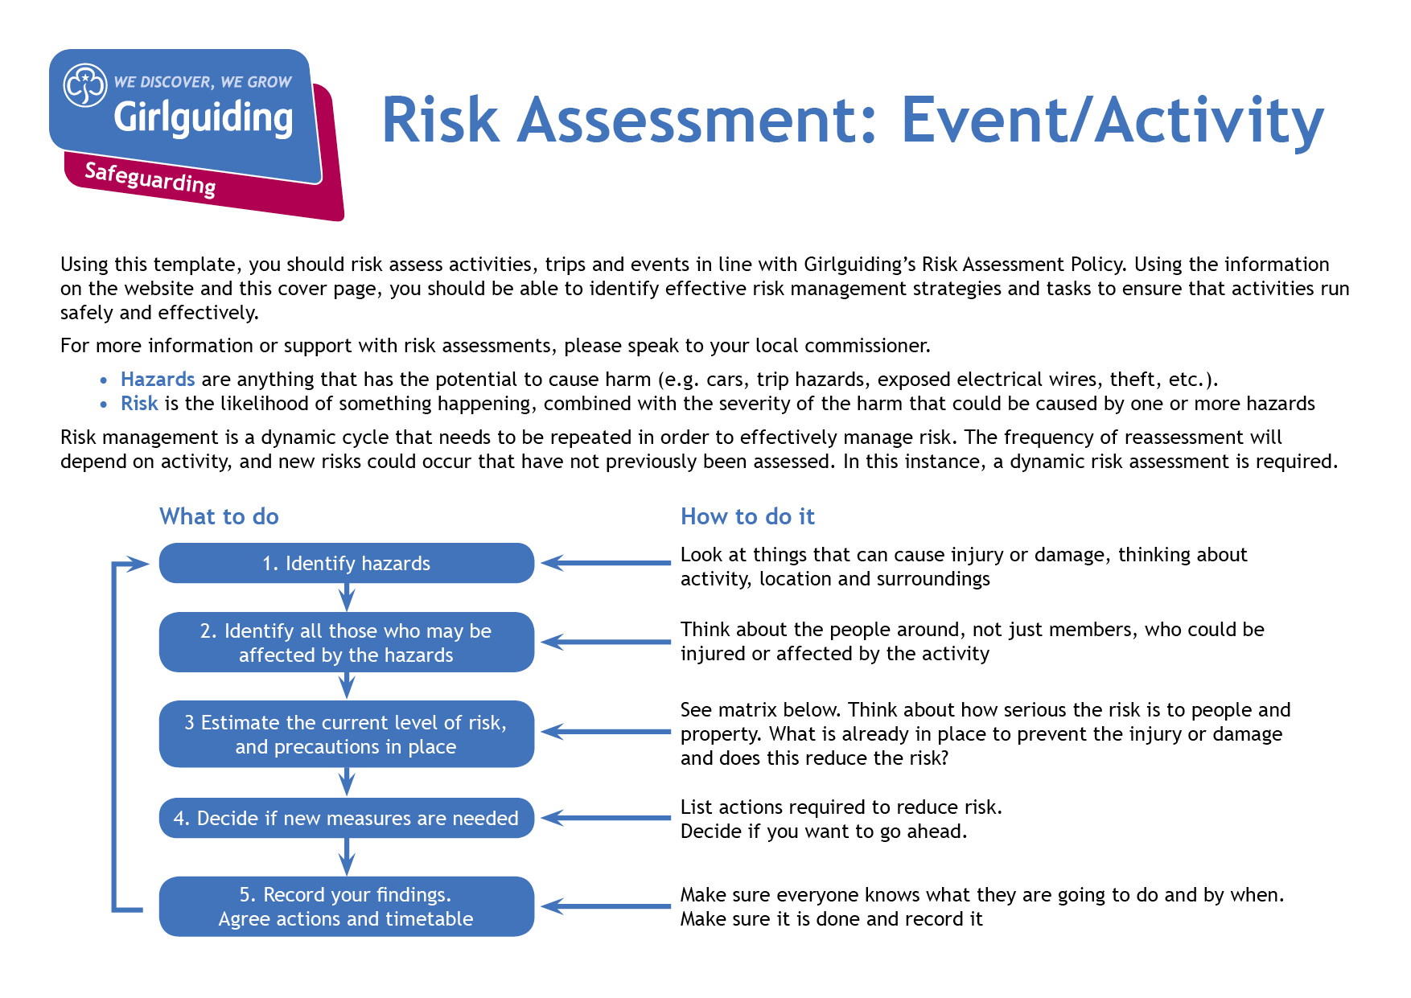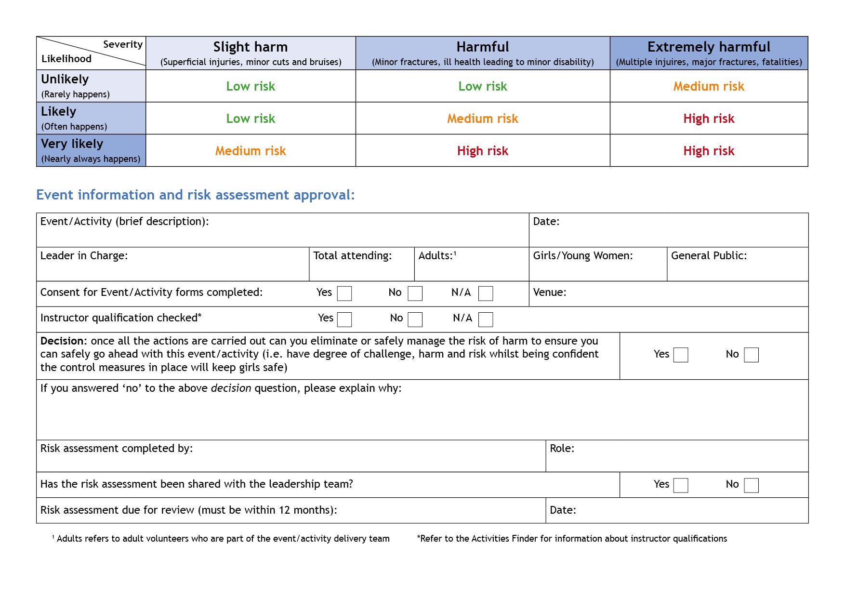

Camp Activity Lead

Anne Esslemont

y

Y

y

Before repeating activity

Bramhope Scout Campsite

13

At least 1

Max 12

Anne Esslemont

None

27th and 28th May 2023

Pioneering

| **Hazards**  What could cause harm or damage? | **Who or what is at risk of being affected and how?** | **What are you already doing?**  How have you reduced the risk already? | **Likelihood of risk occurring**  **(L/M/H)** | **Severity of risk**  **(L/M/H)** | **Are further controls necessary?**  What else needs to happen to reduce the risk to an acceptable level? | **Action by:**  name/date |
| --- | --- | --- | --- | --- | --- | --- |
| Poles | Those participating and in vicinity at risk of being hit or poked with poles or having poles dropped on them |  | L | L | Activity to be done in a clear area with plenty of space. Leader(s) to supervise to ensure sensible behaviour and to remind participants to be aware of where both ends of the poles are. Groups to be spaced apart if more than one group working at once. Participants to be encouraged to work together to lift poles as needed. | Leaders with groups and in activity area. |
| Structure breaking | Those participating and in vicinity at risk of injury from moving parts of structure, falling from structure or sharp edges from damaged poles. | Providing a variety of different ideas and equipment so that groups can choose a project within their capability. | M | L | Activity to be done in a clear area with plenty of space. Leader(s) to supervise to ensure sensible behaviour and awareness of what’s going on. Poles to be checked before use for any signs of damage. Any poles needed to support weight to be checked for strength before use. All structures to be carefully checked by an experienced leader before anyone sits or stands on them (including checking that any knots / lashings are secure). Checks to be repeated after each use.  Anyone sitting or standing on a structure to remain less than a metre off the ground. | Leaders with groups and in activity area |
| Fall from structure | Those participating at risk of upset / injury |  | L | L | Structures designed for sitting or standing on only to be made if a leader with a competent understanding of pioneering techniques is present.  Participants and leaders to check area around structure (or route for stretcher carrying) for anything likely to increase risk of injury if landed on then either remove it or move structure / route to avoid.  Limit the numbers sitting or standing on a structure at a time. Close supervision throughout to watch for any part of the structure moving in a way it shouldn’t be. Position the rest of the group around the structure o hold onto parts of the structure or support the person using it if needed. | Leaders with groups and in activity area |
| Ropes | Those handling them at risk of rope burn, risk of entanglement for participants and those in vicinity | Gardening gloves to be provided for use if wanted | L | L | Activity to be done in a clear area with plenty of space. Leader(s) to supervise to ensure sensible behaviour and to remind participants to be aware of where the rope is and that it isn’t wrapped around anyone. | Leaders with groups and in activity area |

| **Hazards**  What could cause harm or damage? | **Who or what is at risk of being affected and how?** | **What are you already doing?**  How have you reduced the risk already? | **Likelihood of risk occurring**  **(L/M/H)** | **Severity of risk**  **(L/M/H)** | **Are further controls necessary?**  What else needs to happen to reduce the risk to an acceptable level? | **Action by:**  name/date |
| --- | --- | --- | --- | --- | --- | --- |
| Projectiles from ballistas | Risk of injury to people / damage to property in vicinity | Tennis balls / paper balls to be provided for use as projectiles | L | L | Ensure ballistas are angled away from other groups and any property likely to be damaged by being hit by the balls. Participants to be aware of when ballistas are being used and likely direction of fire. | Leaders with groups and in activity area |
|  |  |  |  |  |  |  |
|  |  |  |  |  |  |  |
|  |  |  |  |  |  |  |
|  |  |  |  |  |  |  |
|  |  |  |  |  |  |  |
|  |  |  |  |  |  |  |
|  |  |  |  |  |  |  |