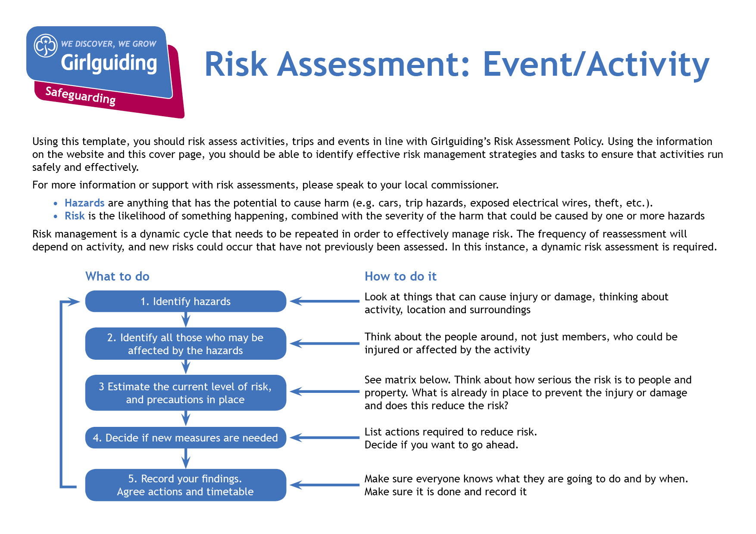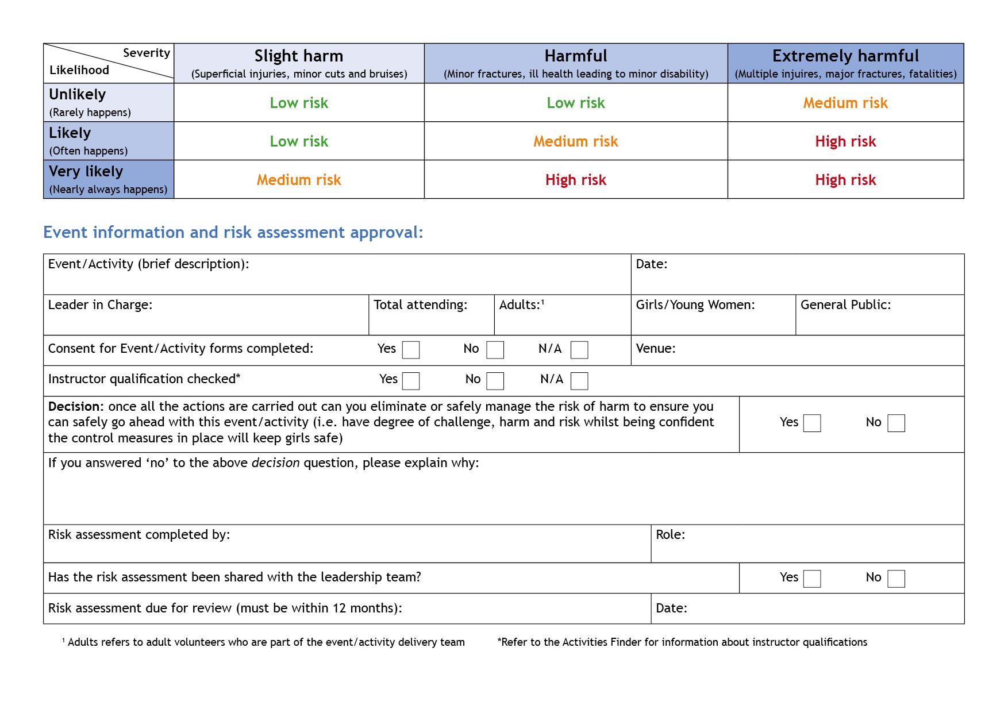xX

Camp Leader in Charge

Carol Bennett

x

X

X

May 2023

Bramhope Scout Campsite & Activity Centre

350

100

250

Carol Bennett

None

26thh-29th May 2023

Leeds County Girlguiding Camp : Be BOLD @ Bramhope

| **Hazards**  What could cause harm or damage? | **Who or what is at risk of being affected and how?** | **What are you already doing?**  How have you reduced the risk already? | **Likelihood of risk occurring**  **(L/M/H)** | **Severity of risk**  **(L/M/H)** | **Are further controls necessary?**  What else needs to happen to reduce the risk to an acceptable level? | **Action by:**  name/date |
| --- | --- | --- | --- | --- | --- | --- |
| Traffic entering and leaving site | All persons controlling traffic into and out of site.  Other motorists and vehicles | * All persons controlling traffic flow to wear High Visibility vests. * Controlled access/egress on and off site * Adequate signage near the campsite entrance warning motorists of the event. * One way system to be put in place. | L | L | One way system to be put in place | Sid Mayhew  Transport Lead  25th May 2023 |
| Accident / collision during vehicular access to and egress from the site car park | Vehicle occupants and pedestrians in parking area | * Strict 5mph speed limit to be signposted and observed * Adult supervision of Car Parking * All vehicles parked in designated areas * Pedestrians to be encouraged to vacate parking area quickly. * Strict one way system on site will be clearly signed * Car Park personnel to wear high visibility vests | L | L |  | Sid Mayhew  Transport Lead  26th May 2023 |
| Accidents during egress from car drop off area | Marshalls in drop off area  Anyone accessing camping areas from drop off area | * All marshals in drop off area to wear high visibility vests. * All persons disembarking from vehicles should be directed to wait instructions from a marshal * Leaders should be waiting to collect campers as a drop and Go system will be in place. * All vehicle movements to be under the direction of a marshal. | L | L | Area to be well signed | Sid Mayhew  Transport Lead  26th May 2023 |
| Accident / collision during vehicular access to and egress from the site camping area | Vehicle occupants and pedestrians in camping area | * With the exception of the site service vehicles, the arrival of Saturday/Sunday activities and in the event of an emergency no moving vehicles to be allowed within the campsite / activity area from **4pm Friday to 12pm Monday.** * All leaders vehicles to be parked in designated Car Parks * Vehicles arriving for Saturday -Monday activities to be escorted at all times whilst in activity area. During build up and take down period: * Strict 5mph speed limit to be signposted and observed * Hazard lights to be used at all times | L | L | Site Vehicles only to be driven by nominated drivers. | Sid Mayhew  Transport Lead  26th May 2023 |
| Slips, Trips and falls due to uneven ground | Anybody on site | * All campers and visitors to be warned of the hazard and informed of the danger of running * Games and activity areas to be carefully selected | H | L | Briefing to young people by Group Leaders | Carol Bennett Leaders Information Prior to Camp |
| Slips, trips and falls or collisions when playing casual games | Anybody on site | * Games areas to be controlled * Games to be supervised by a non playing adult or young leader * Adults to be wary of trying to play like young people! | M | L | Briefing to young people by Group Leaders | Carol Bennett Leaders Information Prior to Camp |
| Accidents during activities | Anybody taking part in activities | * All activities conducted in accordance with Girlguiding Rules * Individual risk assessment to be produced for each activity * Adequate adult supervision to be in place for all activities * Special consideration given to suspending certain activities in bad weather * Qualification of external operators to be checked * All leaders operating activities to understand first aid facilities * ‘Leader in charge’ identified for each activity session. | H | L | Activities team to control | Carol Bennett, Anne Esslemont, Heather Dowling  Checks and Risk Assessments to be completed April 2023 |
| Injury due to carrying heavy loads | Anybody but particularly leaders | * Ask for help and / or use trolleys when available * Share the load * Split down the load wherever possible | L | L |  | Carol Bennett Leaders Information Prior to Camp |
| Injury due to tripping over guy lines and pegs | Anybody but mainly young people | * Large metal pegs on marquees to be fenced/taped off and marked with high visibility tape * Consider taping off other areas between tents * Give advice to all young people of the danger * Tents to be suitably spaced, ideally 2M apart wherever possible | M | L | Briefing to young people by Group Leaders | Carol Bennett Leaders Information Prior to Camp |
| Injury from climbing gates, fences and hedges | Anybody but mainly young people | * Everyone on site to be briefed: * On the areas that are strictly out of bounds * Gates and fences must not be climbed | L | L | Briefing to young people by Group Leaders using information in the final information pack.  Site orientation walk to familiarize the young people with the boundaries of the campsite | Carol Bennett Leaders Information Prior to Camp |
| Contamination of Water | Anybody on site | * Water for drinking, cooking and washing will be available via taps on the camping fields. * Water for drinking, cooking and washing will be available within the site buildings | L | L | Groups to ensure water carriers are sanitised prior to camp | Carol Bennett Leaders Information Prior to Camp |
| Potential food poisoning | Anybody on site | * Central catering for the camp leadership team to risk assess their cooking and food preparation /storage areas * All group leaders to risk assess their cooking and food preparation / storage areas * Good hand washing and/or the use of gloves to be maintained and particularly when preparing / eating food * Ensure food is well cooked * Ensure food is stored safely particularly in hot weather | M | L | Catering teams to monitor | Lynne Baum for Central Catering  Carol Bennett Leaders Information Prior to Camp |
| Food Allergy Management | Anyone with any form of food allergy | * All persons identified on their Camp permission forms as having any form of allergy to have this identified on a wristband * All Activities that have any form of food preparation MUST show a list of all ingredients and allergens. * No young person with a food allergy wristband should be allowed to take part in any activity that relates to their allergy which should be clearly indicated on the wristband they are wearing. | H | H | Leaders to control issuing of wristbands  Activity providers to show list of ingredients and allergens and check for allergies on wristbands  Group Leader to discuss food activities with the young people with food allergies and to confirm the activities they can take part in | Carol Bennett Anne Esslemont, Heather Dowling |
| Cuts and contamination to feet | Anybody on site | * Suitable footwear to be used at all times * No bare feet / socks on general camp site or to and from activity area * If an activity requires bare feet then the risk must be assessed and control mechanisms put in place to prevent injury | L | L | To be briefed by Group Leaders and Activity providers | Carol Bennett Leaders Information Prior to Camp |
| Risk of infection to minor cuts and grazes | Anybody on site | * Ensure that all cuts and grazes however minor are properly cleaned and if necessary covered * Ensure all cuts and grazes however minor are recorded | L | L | Brief to group leaders / first aiders | Jane Bunyan and Groups First Aider  26th-29th May 2023 |
| Sun Burn/Sun Stroke | Anybody on site | * In the event of sunny weather:   + Use of hats encouraged   + Sun cream to be available and used   + Use shaded areas for eating etc. * Ensure plenty of liquid consumed to avoid dehydration | M | M | Young people to be briefed and ensure sun screen is available and applied and sun hats worn | Jane Bunyan and Groups First Aider  26th-29th May 2023 |
| Dehydration | Anybody on site | * Water available throughout camp * Brief Young People on the signs of dehydration | L | L | Group leaders and those running activities to remind girls throughout event as needed | Jane Bunyan and Groups First Aider  26th-29th May 2023 |
| Asthma attacks and other medical issues | Those with medical conditions | * All participants to supply a completed health form * Groups and camp HQ to hold a copy of all forms * All medication for young people to be stored and controlled by the Group Leader * Any camp participant with a medical condition will be required to wear a coloured wristband completed by their group leader so that activity leads are aware. * Group Leader to be aware of First Aid location at camp and provision during the night. | M | H |  | Jane Bunyan and Groups First Aider  26th-29th May 2023  Health Forms to be supplied before camp. Leaders to be informed of First Aid location 26th May 2023 |
| Illness due to lack of personal hygiene | Anybody on site | * Toilets to be regularly inspected by Service Team for cleanliness * Hand washing/sanitizing facilities to be provided at toilet area and in camp * Young people encouraged to regularly wash their hands and particularly after activities involving contact with the ground and before eating. | L | L | To be managed by service team and checks made regularly  All Leaders to ensure toilet areas kept clean  Groups asked to provide washing facilities on campsites | Claire Kilburn  25th-29th May 2023 & Group Leaders |
| Spread of minor illnesses | Anybody on site | * Anybody experiencing or caring for a young person who suffers from vomiting and/or diarrhoea must report this immediately to the camp management team or camp first Aider * The patient should be isolated from other campers and arrangements made for them to leave the camp as soon as possible. * Toilets used by the patient should be identified and closed until fully disinfected. | M | L |  | Jane Bunyan and Groups First Aider  26th-29th May 2023 |
| Chemical injury from cleaning fluid etc | Anybody on site | * All such chemicals / liquids to be clearly labelled in a proper storage container * All such chemicals / liquids to be stored out of sight and reach of young people * Suitable protective clothing to be used by adults when using chemicals / liquids * Chemicals/liquids in use on the campsite need to comply with the campsite guidance | L | L | To be controlled by Group Camp Leader | Carol Bennett Leaders Information Prior to Camp  Claire Kilburn Service team 26th – 29th May 2023 |
| Risk to/from contractors working on the site build up | Contractors and anybody on site | * All contractors to be briefed on site safety standards prior to commencing work * Camp infrastructure team to satisfy themselves that a safe working method is used | L | L | Infrastructure team to control.  Activity field to be closed/out of bounds to young people until activities set up | Carol Bennett 24th – 26th May 2023 |
| Use of powered machinery | Adults but low risk to young people | * Any powered equipment to be used on site must be approved by the infrastructure team prior to use * The user must be trained to use the equipment * Appropriate PPE must be used * Powered equipment to be used only by adults and away from young people * Powered equipment to be stored securely away from young people | M | M |  | Carol Bennett 24th – 26th May 2023 |
| Generators – risk of fire, electrocution and trips from cables etc. | Anybody on site but mainly adults | * All generators to be approved by the infrastructure team prior to use * The user must be trained to use the equipment * The equipment must be located in a safe place away from young people * Fuel must be safely stored in suitable containers away from young people * Generators to be earthed in accordance with instructions * Cables to be buried, pegged to ground or fenced off | L | L | Infrastructure team to control | Carol Bennett 24th – 26th May 2023 |
| Fire – Use of Open Fires | Anyone in immediate area of any fire | * Groups to bring own wood or charcoal * No Fire Pits to be dug. * Altar fires only to be used with the permission of the infrastructure team. * Any fire to be a minimum of 7m from any tent * Fires not to be left unattended (by an adult) and to be doused after use. * Consider taping a safety area particularly if younger members are present * Ensure fire buckets are available close to fires | L | L | Infrastructure team to authorise groups using fires and to monitor | Carol Bennett Leaders Information Prior to Camp |
| Fire in tents | Anybody on site | * Tents to be positioned (where possible) with a 2m gap between them * Cooking tents to be 6m from sleeping tents (canvas to canvas) * Suitable fire buckets /extinguishers to be available * Naked flames only to be allowed in cooking and eating tents – this to include gas lamps * No naked flames on gas burners etc. to be left unattended * No smoking in tents * Gas bottles to be stored outside of tents in the open air and more than 6m from any sleeping tent * Gas bottles to be turned off when not in use * Hoses and regulators checked for good condition. Hoses secured to equipment by hose clips * Battery torches only in sleeping tents * Ensure exits are clear at all times and marked in larger tents/marquees | L | L | Gas will be used for cooking purposes only.  Group leaders to be briefed that any lanterns brought must be battery operated. | Carol Bennett Leaders Information Prior to Camp |
| Members of public on camping field | Mainly young people | * All adults to be aware and to challenge strangers. * Camp attendees to be identified by them wearing blue lanyards. * Camp visitors to be identified by them wearing black lanyards. All visitors to sign in on arrival and out on exit. | L | L |  | Carol Bennett Leaders Information Prior to Camp |
| Young people wandering off and getting lost | Young people | * Camp boundaries to be well marked and explained to all young people * All Leaders to make sure young people know of importance of not wandering off alone. * Leaders have head counts at key times e.g. at meal times * Young people to be encouraged to operate a “buddy” system. | L | L | Briefing by group leader  Maps provided to all participants | Carol Bennett Leaders Information Prior to Camp |
| Accident Involving Site marker posts/pegs | Anyone on site | * All campers to be made aware of risk from sharp points if markers are removed * All loose markers to be either replaced or given to Infrastructure team. | L | L | Site marker posts/pegs marking the boundary of the group camping area will be replaced or removed if they become loose | Carol Bennett Leaders Information Prior to Camp |
| Extreme Weather | Anybody on site | * Ensure adequate equipment and clothing * In extreme conditions camp management will consider cancellation * Shelter available in marquees and buildings * Obtain and use weather forecasts | L | L | Monitor weather and campsite conditions throughout event and consider early finish if required.  Remind leaders to ensure that parents are aware they may be required to collect early. | Carol Bennett Leaders Information Prior to Camp |
| Camp Management | Anybody on site | * All leaders and helpers to have completed appropriate checks and mandatory training. * Event run by leaders with appropriate licences, correct permissions for events gained and risk assessments completed * All camp planning documents accessible to all camp team and deputies identified where possible so that camp could continue in the event of a team member being unable to attend * Central First Aid provision for Group Leaders to access * Central Admin and Information provision for leaders to access * Appropriate child/adult ratios in place at all times. Group Leaders to consider whether extra adult help is required for the event and/or specific child(ren). * Suitable first aid cover is in place * Details of A&E, hospitals and local doctors * Ensure robust home contact system is in place * Medication to be secured securely and leaders to supervise schedule of taking medicines | L | L | Camp management team to monitor processes throughout camp and make changes and hold leader meetings if needed | Carol Bennett Leaders Information Prior to Camp |
| Behaviour of Participants | Young People | * Clear expectations to be given to young people and parents before the start of camp. * Campsite rules to be communicated to Group Leaders and enforced e.g. quiet times, camp boundaries. * Group leader to monitor behaviour | L | L |  | Carol Bennett Leaders Information Prior to Camp |
| COVID | Anybody on site | * Young people not to attend camp if they show signs of COVID and have a positive lateral flow. (communicated at parents evening and the subject of a separate email) * Young people and adults to be isolated if show signs of COVID at camp and have a positive lateral flow and sent immediately home. * Camp area to be disinfected * Where the adult may be a camp leader another leader is attending with a campers licence. * Where other adult leaders are affected (First Aider/Catering) other Guide leaders are attending that can switch to ensure ratios are maintained. There are sufficient adult leaders to cover the ratios on the camp site. * All current girlguiding guidelines for COVID are to be followed. | M | L |  | Carol Bennett Leaders Information Prior to Camp  Jane Bunyan Camp First Aider 26th-29th May 2023 |
| Financial Loss due to cancellation of the Camp | County and groups attending | * The organisers of the camp have taken out insurance to cover the possibility of the camp being cancelled. * The payment received for camp comprises a camp fee payable to the Leeds County Girlguiding for activities and camp fees and an element retained by groups for food. If the camp is cancelled before the food element is spent, this can be returned directly to the participant from the group. | L | L | It would be in extreme circumstances that the camp would be cancelled. | Carol Bennett |
| Major incident | All | * A major incident folder is available and held in a central location which is accessible by all of the camp organising team. * The major incident folder will contain Girlguiding information of what to do in an emergency, flowcharts, forms, emergency contact details. It will identify roles and responsibilities for team members and what to do in different scenario's such as Fire and evacuation, medical emergency and extreme weather etc. | L | H | If a major incident occurs the Emergency Services would be called who would assist the Camp Team. | Camp Organising Team |
| Unanticipated risk | All | * Information point available for leaders to raise any issues they become aware of | L | L | Camp team to conduct dynamic risk assessments throughout event and to introduce controls as needed. | Camp Organising Team |