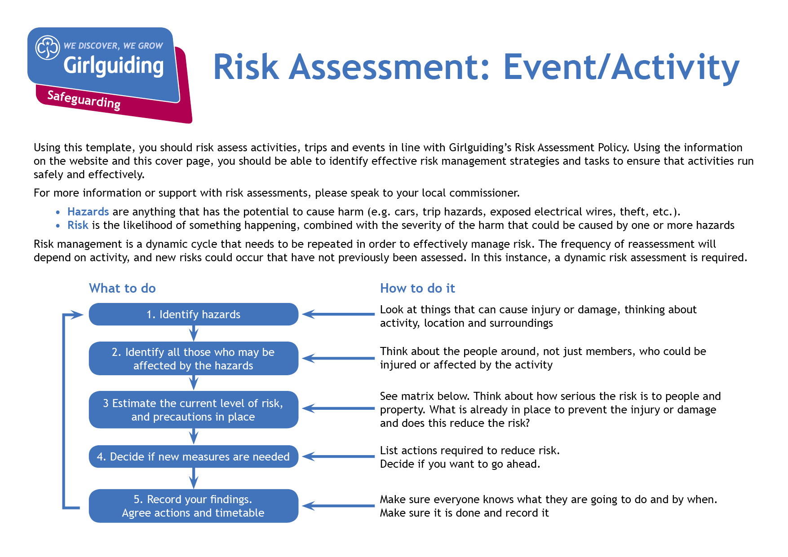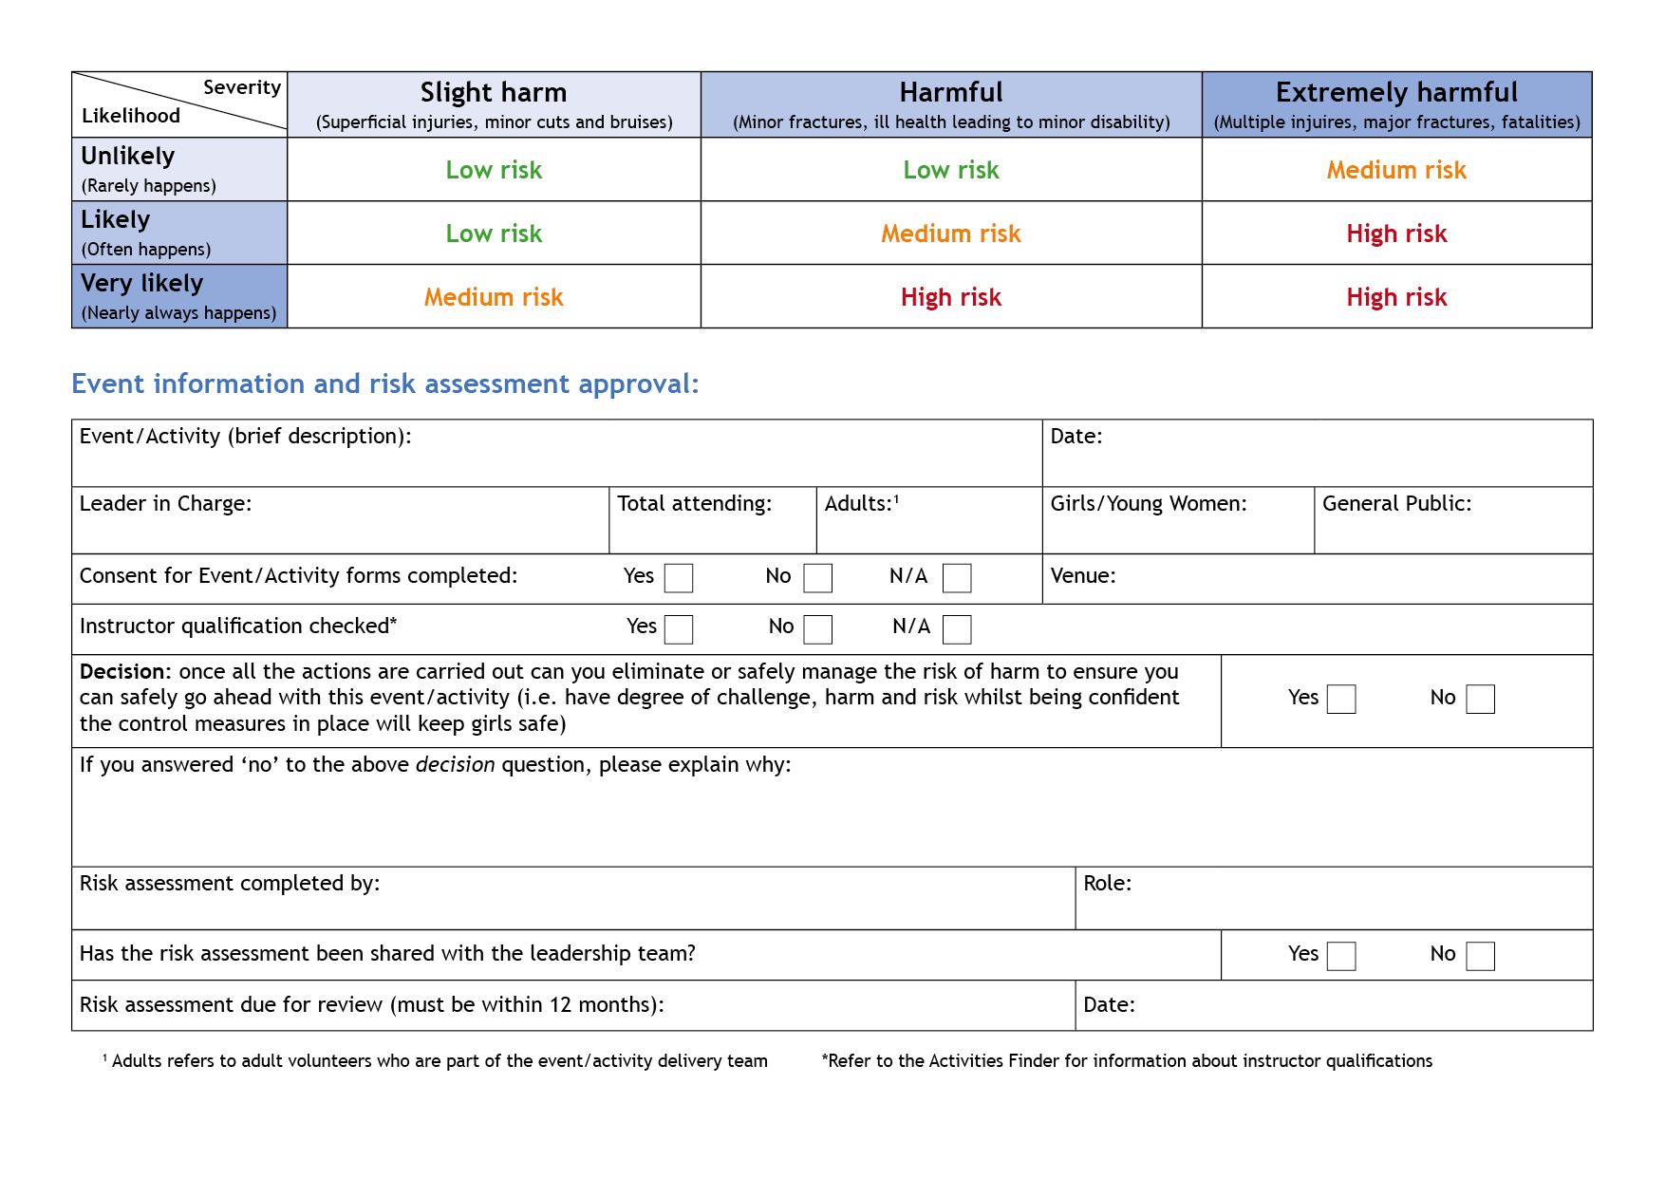T

Activity Lead

Anne Esslemont

y

Before repeating event

Bramhope Scout Campsite

13

At least 1

Max 12

Anne Esslemont

none

27th & 28th May

Slacklining

| **Hazards**  What could cause harm or damage? | **Who or what is at risk of being affected and how?** | **What are you already doing?**  How have you reduced the risk already? | **Likelihood of risk occurring**  **(L/M/H)** | **Severity of risk**  **(L/M/H)** | **Are further controls necessary?**  What else needs to happen to reduce the risk to an acceptable level? | **Action by:**  name/date |
| --- | --- | --- | --- | --- | --- | --- |
| Falls from line | Those on the line and in the area at risk of injury |  | L | M | Slackline to be set no more than 1 metre off ground.  Activity to be supervised by an adult throughout to ensure sensible behaviour and adherence to rules.  Leaders to ensure only 1 person on the line at a time.  Participants to be advised on how to use the line and to have a spotter on either side, holding hands initially and once confidence grows, walking alongside to be available to support if needed.  Trainers or similar suitable footwear to be worn. | Leaders with groups and in activity area during sessions |
| Ratchet mechanism | Anyone touching or operating the mechanism at risk of injury |  | L | L | Line to be set up by an adult with experience of use. Activity to be supervised by an adult throughout. Line to be checked after each session and tightened if necessary. Care to be taken when tightening to avoid catching fingers in mechanism. Participants to be advised not to stand on or touch mechanism. | AE to set up / check at the start of each session  Leaders with groups and in activity area during sessions |
| Incorrect setup | Line and trees at risk of damage and increased risk of falls | Bramhope slackline is permanently in position | L | L | For additional slackline: Trees used to be at least 20cm in diameter. Sacking to be used between tree and slackline to protect tree Line to be checked for correct setup before first use | Leaders with groups and in activity area during sessions |
| Incorrect use | Line and trees at risk of damage and increased risk of falls |  | L | L | Activity to be supervised by an adult throughout. Leaders to ensure only one person on the line at a time.  Leaders to ensure that participants only do activities within their capability.  Spotters to be briefed that they should allow the person on the line to control how much they hold on. | Leaders with groups and in activity area during sessions |
| Surrounding area | Trip hazards for spotters and increased risk of injury to participants if objects to fall on |  | L | L | Position to be chosen so that the space around and under the slackline is clear and so that the area underneath is grass or soft ground. There should be a clear path for spotters to walk on either side of the line. Participants who are not spotting or on the line to keep far enough back to allow space for spotters and not to risk touching the line. | Leaders with groups and in activity area during sessions |
| Participant gripping spotters | Injury to spotters through repeated use of same arm or excessive force from participant |  | M | L | Spotters will ideally be adults or girls taller than those using the line so that they can hold hands above shoulder height to give better support and also to decrease risk of injury. Spotters to swap round so that they are not constantly supporting with the same arm. | Leaders with groups and in activity area during sessions |
| Silly behaviour due to boredom | Increased risk of injury and upset to participants | Planned as drop in activity | L | L | Activity to be supervised and different challenges to be set for each turn:  Challenge 1: stand on slack line on one leg with 2nd leg dangling  Challenge 2: walk from one end of line to the other holding onto spotters as needed.  Challenge 3: walk from one end of line to the other then hug the tree to turn round and walk back to the start.  Challenge 4: walk to the middle of the line, squat down and stand up again then continue to the end.  Challenge 5: attempt one or more steps without holding on to spotters or just holding on one side | Leaders with groups and in activity area during sessions |

| **Hazards**  What could cause harm or damage? | **Who or what is at risk of being affected and how?** | **What are you already doing?**  How have you reduced the risk already? | **Likelihood of risk occurring**  **(L/M/H)** | **Severity of risk**  **(L/M/H)** | **Are further controls necessary?**  What else needs to happen to reduce the risk to an acceptable level? | **Action by:**  name/date |
| --- | --- | --- | --- | --- | --- | --- |
|  |  |  |  |  |  |  |
|  |  |  |  |  |  |  |
|  |  |  |  |  |  |  |
|  |  |  |  |  |  |  |
|  |  |  |  |  |  |  |
|  |  |  |  |  |  |  |
|  |  |  |  |  |  |  |
|  |  |  |  |  |  |  |