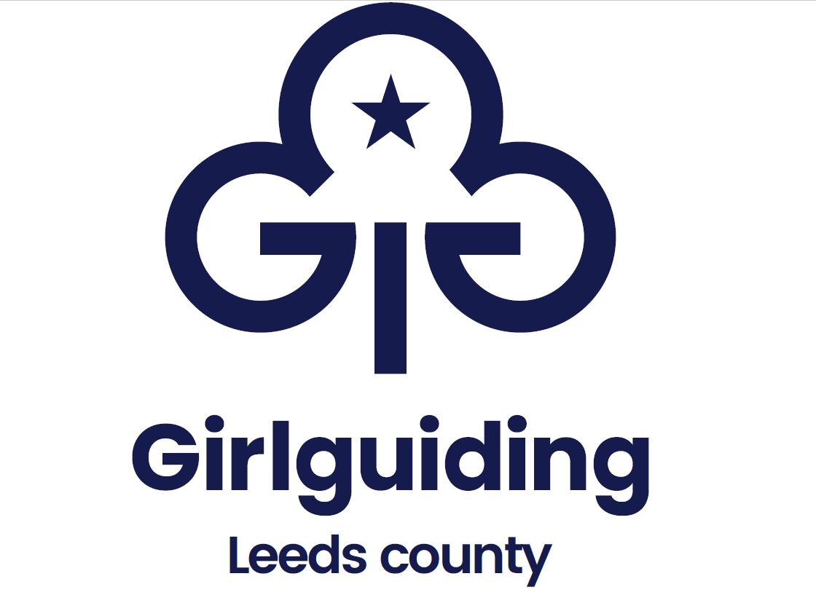
Long Service Award Order Form
Request From:
Division:
Email:
Length of Service awards required for (please tick)

 | 5 Years (£3) |  | 10 Years (£17.50)
Awards required

Name (for certificate) | Award | Cost | Total cost
 |  | £
 |  | £
 |  | £
 |  | £
 |  | £
 |  | £
 |  | Total
Delivery method (please tick)
(due to the cost of the awards we will not post these out to you unless by specific request).

Collection at County Exec/Office (please do not come to collect until you have received an email acknowledgement that your order is ready.)
Collection from Skyrac Depot by prior arrangement (please do not come to collect until you have received an email acknowledgement that your order is ready.)

Please send the completed form with your payment to:
County Administrator, The Trefoil Centre, 16a Morris Lane, Kirkstall, Leeds, LS5 3JD
badgesecretary@girlguidingleeds.org.uk

Information provided on this form will be processed by Girlguiding Leeds in accordance with the Data Protection Act 1998. The data you provide will only be used for processing your award application. The information will not be shared with other organisations.
For office use only: | Request form received | Payment received | Badges sent

Notes for completing this form:

Postage costs
Due to the cost of the long service awards these must be collected rather than posted. If you would prefer for them to be posted please contact the office for a price for recorded delivery.

Payments
Payments may be made by cheque or BACs. Please do not send cash in the post.

- Cheques should be made payable to Leeds County Guide Association.
- BACs payments can be made to Leeds County Guide Association, Sort Code: 40-52-40; Account No: 00024618; Reference: LSA.

Confirmation
You will receive a confirmation via email that your awards have been sent.

Queries
If you have any questions about ordering Long Service Awards, please contact the Badge Secretary at badgesecretary@girlguidingleeds.org.uk

